Workflow Functionality

Best Practice Guide

Microsoft Office Project Portfolio Server 2007

_________________

Microsoft Office Project Portfolio Server 2007 – WorkFlow Functionality – Best Practice Guide
Applies To:
Microsoft Office Project Portfolio Server 2007

Summary:
This guide describes the workflow functionality and configuration for Microsoft Office Project Portfolio Server 2007 and provides examples for the workflow setting.

The information contained in this document represents the current view of Microsoft Corporation on the issues discussed as of the date of publication. Because Microsoft must respond to changing market conditions, it should not be interpreted to be a commitment on the part of Microsoft, and Microsoft cannot guarantee the accuracy of any information presented after the date of publication.
This document is for informational purposes only. MICROSOFT MAKES NO WARRANTIES, EXPRESS, IMPLIED OR STATUTORY, AS TO THE INFORMATION IN THIS DOCUMENT.
Complying with all applicable copyright laws is the responsibility of the user. Without limiting the rights under copyright, no part of this document may be reproduced, stored in or introduced into a retrieval system, or transmitted in any form or by any means (electronic, mechanical, photocopying, recording, or otherwise), or for any purpose, without the express written permission of Microsoft Corporation.
Microsoft may have patents, patent applications, trademarks, copyrights, or other intellectual property rights covering subject matter in this document. Except as expressly provided in any written license agreement from Microsoft, the furnishing of this document does not give anyone any license to these patents, trademarks, copyrights, or other intellectual property.
Unless otherwise noted, the example companies, organizations, products, domain names, e-mail addresses, logos, people, places, and events depicted herein are fictitious, and no association with any real company, organization, product, domain name, e-mail address, logo, person, place, or event is intended or should be inferred.
© 2007 Microsoft Corporation. All rights reserved.
Microsoft, ActiveX, Excel, Internet Explorer, SharePoint, Visual Basic, Windows Server, Windows Vista, and Windows are either registered trademarks or trademarks of Microsoft Corporation in the United States and/or other countries.
The names of actual companies and products mentioned herein may be the trademarks of their respective owners.

Contents
Contents iv
Introduction 6
Project Portfolio Management and Workflows 6
The Scope of This Guide 6
The Audience 7
Guide Chapters 7
Workflow Functionality 8
Portfolio Decisions and Governance Principles 8
The Use of the Workflow as a Governance tool 8
Workflow Concepts 9
Workflow Components 11
Phases 12
Lifecycle Steps 13
Transitions 15
Processes (Verification and Link) 16
Notifications 17
Email Templates 19
Defining the Workflow 21
Guidelines and Best Practice for Architecting Workflows 21
Architecting the Workflow – An Example 23
Workflow Configuration 36
Workflow Management - Overview 36
Governance Phase Management 37
Workflows Management - Naming and Linking to Projects 37
Verification and Link Processes Management 38
Email Templates 39
Workflow Notification Management 40
Lifecycle Step Management 42
Setting the Lifecycle Step - Access to Project Tabs 44
Transitions and Sequencing 45
Workflow Use Cases 47
Assign and View the Workflows for Projects 47
Transitioning Projects through the Lifecycle 50
Alert Subscription for Workflow Step Change 51
Reporting 54
Workflow changes 56
Modifying the ‘Project Class’ Attributes 57
Other Workflow Related Uses 58
Working With Portfolio Server without a Workflow 59
Appendix 60
References 60

chapter

chapter | Introduction

Project Portfolio Management and Workflows

Microsoft Office Project Portfolio Server 2007 uses the most advanced best practices of project portfolio management (PPM) methodology that have been developed over the last two decades. The methodology allows organizations to derive optimal value from project portfolio investments by aligning portfolios with the organization’s business strategy and optimizing investments based on budgetary constraints.
The guiding principle behind the methodology is to enhance the organization’s decision-making process when creating, selecting, planning, and managing portfolios of project initiatives. This process is often quite complex and requires the collaboration and buy-in of many people with different opinions and experiences, while supporting diversified organizational needs and goals.
To support an effective decision-making process, Microsoft Office Project Portfolio Server 2007 offers a workflow module that allows managers to structure the governance principles of their decisions throughout the lifecycle of their projects. The workflow module organizes the project lifecycle into steps and, for each step, managers can define the scope of work required, assign responsibility, and set automatic notifications to inform or call for action.
Using the workflows, organizations can orchestrate the decisions and actions required to create, select, plan, and manage the right set of projects as benefit-yielding portfolios.

The Scope of This Guide
This guide concentrates on the development and configuration of workflows. It provides an overview of the governance principles for portfolio management and shows how Microsoft Office Project Portfolio Server 2007 workflows support them. To illustrate this, the guide offers a generic example that takes the reader through the definition and setup of workflows.
The guide assumes that the reader has a basic understanding of related configuration topics such as organization, finance, attributes, user setups, and the builder project tabs and their functions. When describing the configuration steps, the guide also assumes that these and other related requirements are already configured.
The guide does not intend to provide a workflow solution for each possible case, but rather to offer guidelines. Readers should use the information in this guide as a starting point and employ creativity and good judgment in setting up their own workflows.
Although the workflow is a key part of the portfolio governance process, other governance elements that are not part of the workflow are required for good portfolio management. Some examples are the definitions of project and portfolio types, strategic decision criteria, and procedures that identify the timing and the methods for project evaluation. Each organization should define these elements as part of their governance principles to ensure effective and efficient portfolio management.

The Audience
This guide is intended for users who are in the process of setting up Microsoft Office Project Portfolio Server 2007 and want to learn about best practices for workflow setup.
For users who intend to be the tool administrators, the guide provides information regarding workflow maintenance and administration as well as rationale for maintaining good governance structure.

Guide Chapters

The guide is organized into several chapters that describe the purpose, principles and uses of such workflows in order to simplify the understanding of how to design and configure workflows:
Chapter 1, “Introduction”, briefly describes the use of workflows to support portfolio and project decisions, identifies the content of the guide and the audience it aims to support.
Chapter 2, “Workflow Functionality”, describes the basic premise behind workflow operation.
Chapter 3, “Defining the Workflow”, describes the planning process for building workflows.
Chapter 4, “Configuring the Workflow”, explains how to configure workflows within the Microsoft Office Project Portfolio Server 2007.
Chapter 5, “Portfolio Use Cases”, illustrates some of the applications of workflows.
Chapter 6, “Additional Settings”, describes other settings in Microsoft Office Portfolio Server 2007 that relate to workflows and their use.
Chapter 7, “Appendix”, includes various helpful information.

chapter

chapter | Workflow Functionality

Portfolio Decisions and Governance Principles

Business organizations are complex entities that support diversified needs and goals: financial, social, or others. These needs and goals affect customers, shareholders, and employees and are impacted by competition, legislative organizations, and market changes. They also generate requirements for many project initiatives that compete for the organization’s shared and limited resources.
Each project initiative demands a different level of investment, carries different risks, and offers different levels of support for the organization’s needs and goals. Considering resource limitations, organizations must select the right combination of projects in which to invest.
To make the best decisions, organizations must coordinate stakeholders’ actions, create buy-ins, and maintain flexibility for future change. They must create a governance process that identifies the method by which to carry out decisions, the actions to be taken in each step, the data that supports the decisions, the actors’ responsibilities and accountabilities, and the communication between all stakeholders involved.
From the portfolio management point of view, the governance process should also dictate methods for submission of project proposals, review and selection of projects, and analysis and reporting throughout the lifecycle of the projects.

The Use of the Workflow as a Governance Tool
Microsoft Office Project Portfolio Server 2007 (Portfolio Server) allows organizations to create workflows that subject each project to the appropriate governance controls and processes throughout its lifecycle. It allows organizations to define multiple workflows to help manage different types of projects.
All workflows within an organization are structured under one unifying set of governance phases. The phases are the common denominators that allow an organization to aggregate and report on projects across all their workflows.
Each workflow is composed of a series of lifecycle steps, and each step defines the actions and responsibilities required for the project to move forward.
The combination of the overarching governance phases, the multiple workflows, and the chain of lifecycle steps provides a solid mechanism for the portfolio governance process.

Workflow Concepts
A workflow is a collection of lifecycle steps defined for a specific project type and structures the operational aspect of project lifecycle management. It organizes the project lifecycle steps in pre-defined high-level governance phases and defines what tasks to perform, who performs them, when, and in what order.

Organizations can set up workflows that define the lifecycle steps for their projects from idea inception, through various data collections and reviews, to project completion and benefit realization. The lifecycle steps control the access to the project data repository, actions, and transitions. They also use automatic notifications to alert the appropriate users about a project’s status, and actions required to continue with the lifecycle step handoffs.
For every new project, the user identifies the type of workflow the project will follow by selecting an instance from the ‘Project Class’ attribute list that appears in the ‘Project Info’ tab. The project then starts at the first lifecycle step for this workflow. From that point on, the lifecycle steps control the access to project tabs and set them to be either Invisible, Editable, or Read-Only. As users add data to the various tabs, the project can move on to the next lifecycle step, in which additional accesses, limitations, and/or requirements are introduced. This process continues until the project is completed and benefits are realized.
Several individuals are involved with the project throughout its lifecycle. These individuals are associated with different user groups based on their responsibilities, levels of authority, and distinct project duties. The workflow uses these user groups to determine which users have access to the project at which lifecycle step.
Workflow Scalability
The workflow module in Portfolio Server supports any number of workflows tailored for different project types and organization-specific business rules. For example, small, mandated projects may have a workflow with less rigid reviews and controls than a larger, more complex project. On the other hand, R&D projects may have more reviews and controllers. Each type of project can have its own workflow with the appropriate level of details.
Workflow Features

Workflows use the following features to allow organizations to enable the required governance standards for all types of projects:
- The workflows consist of a series of lifecycle steps that subject a project to the appropriate governance controls throughout its lifecycle.
- Governance Phases are common phases shared by all workflows and are used to aggregate projects across multiple workflows.
- Every workflow can be associated with one or more instances of the ‘Project Class’ attribute list of instances, however there can be only one workflow for each value of ‘Project Class’.
- When a project is created and the ‘Project Class’ instance selected, the project automatically proceeds to the first lifecycle step of the associated workflow.
- A lifecycle step is a standardized step of a project where information about that project is entered or reviewed.
- Every lifecycle step includes a notification to a certain user group. Users belonging to this group can move the project forward to the next lifecycle step.
- User groups define each user’s role in managing the project and to determine the type of access to the project each user should have.

Figure 2-1 illustrates the key principles of workflows. It highlights one lifecycle step and one transition, depicting the elements that need to be considered for each.

Next step option 1
Next step option 2
Back step
Lifecycle step:
- Must do
- Notify
- Can/Cannot do
Transition:
- Must do
- Notify
Figure ‎2-1 Lifecycle Step and Transition

The figure identifies three elements that need to be set for each lifecycle step:
- Must do: a set of actions that must be completed before the project can move to the next step (Verification Process).
- Notify: a message to users in a specific user group that need to take responsibility for the project in the current step.
- Can/cannot do: a set of permissions to access project information tabs (for each workflow step and each tab the access level could be: Editable, Read-Only, or Invisible).
The figure identifies two elements for each transition:
- Must do: a set of actions to be performed automatically once a project goes through that transition (Link Process).
- Notify: messages to users in specific user groups to notify them about the current transition event.

Workflow Components

The workflow includes several components that establish a blueprint for the organization’s governance framework, and help ensure that all projects complete the necessary deliverables, and receive the required managerial sign-off, before moving from one lifecycle step to another.
- Governance Phases – common phases across all workflows that are used to aggregate projects from multiple workflows. The phase may include one or more lifecycle steps.
- Lifecycle Steps – govern the actions, the user responsibilities, and the notifications required in each stage of the project’s lifecycle. The step also defines its data access rights to the project tabs.
- Transitions – identify the potential next steps for each lifecycle step, the actions, and notifications required when the transition takes place.
- Verification Process – a set of actions that must be completed before the project can move on to the next step.
- Link Process – a set of actions that are activated automatically as the project transitions to the next lifecycle step.
- Notifications – messages sent to inform or alert users about the project’s required actions or the project transition. Notification may request a ‘sign-off’ and comments that will register in the audit trail.

Figure 2-2 illustrates an example of the way governance phases and lifecycle steps are organized.

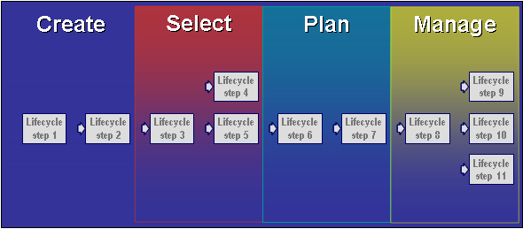
Figure 2-2 Workflow Governance Phases and Lifecycle Steps

Phases
The workflow is divided into several generic governance phases. The configuration of governance phases will be different for different organizations, depending on their particular needs and methods. Organizations may create any number of phases. This number should be large enough to provide the required details, yet small enough to make the process easy to manage. A good number of phases is between three and eight. Outside these guidelines, the phases may not be effective or user friendly. The example in this guide uses four phases, which in many cases proves to be the optimal number. These phases are named: Create, Select, Plan, and Manage.
The Create Phase
The Create Phase includes all the lifecycle steps that define a project from an idea to a complete initiative that is ready to go through the selection process. Depending on the organization’s requirements, users enter quantitative and qualitative data into the project tabs. The data could include costs, resources requirements, schedule, benefits, risks, and an assessment of the project’s contribution to the portfolio’s strategy. During the Create Phase, a project portfolio manager monitors the project ideas throughout their development steps by reviewing the Builder Scorecard. At the end of this phase, a project will either be suspended or move on to the Complete Request step, which calls for additional input to detail the project plan and create a baseline for funding approval, and prepares the project for the Select Phase.
The Select Phase
The Select Phase introduces a key concept to Project Portfolio Management: the structured approach to funding approval using the Optimizer analysis capabilities. It includes the lifecycle steps in which projects are evaluated, prioritized, and selected or rejected, based on the impact on business drivers and budgetary constraints. At the end of this phase, a project will move either to the Rejected step or to the Select step based on the Optimizer analysis. Once selected, the project will await the assignment of a project manager and transition to the Planning Phase.
The Planning Phase
The Planning Phase includes the lifecycle steps that bring the project plan to completion and ready the project for the final approval before execution. Here, the baseline plan for funding is finalized. At the end of this phase, a project will transition either to the Suspended step or to the Request Approval step. Once approved, the project will await the assignment of a project manager (if change is required) and then transition to the Deliver step for its execution.
In this phase, the Project Portfolio Gateway is introduced. The gateway allows projects to be exported to Microsoft Office Project Server 2007 and to Microsoft Office Project Professional 2007 for detailed planning. As the plans are detailed, the data is synchronized with Portfolio Server to allow for proper management of the portfolios.
The Manage Phase
The Manage Phase includes all lifecycle steps that track the project execution and retirement. During the Manage Phase, project managers update their projects with new cost and resource forecasts and actual data, phase-level of percent completions, and create periodical snapshots of this data. When the project is completed it moves on to a ‘Post-Completion’ step in which managers track post implementation benefits. Portfolio managers and executives can track projects and the portfolios in the Dashboard module. The data synchronization between Project Server and Portfolio Server will continue in this phase as needed.

Lifecycle Steps

Lifecycle steps are the building blocks of the workflow. They control the actions, the notifications, and the accesses to project data. Except for special cases, the number of steps should be between 10 and 30 in order to maintain a good level of control without making the workflow too complex. A lifecycle step is defined by:
- Name, represents the nature of the step; shown as ‘Workflow Status’ in the Builder module.
- Display Name, shown on the workflow graph in the Builder.
- Governance Phase the step belongs to, shown in the Workflow chart.
- Objective, defines the purpose and the process of the step in as much detail as possible; shown in a pop-up balloon on workflow graph.
- Associated Default Notification, the notification assigned to the step; each step requires one notification:
    - Automatic Lifecycle Step requires a notification with feedback to notify users that they must sign-off on the work done and provide comments before the project can move on to the next step. The sign-off requirements could be for a single user, multi-users, or multi-users in a specific sequence. If there is one next step, the project will move automatically to the next step once the required users sign-off.
    - Manual Lifecycle Step requires a notification with feedback to notify users that they must sign-off and provide comments, and move the project manually to the next step.
    - Manual Lifecycle Step requiring a notification without feedback: no sign-off is required and every notified user can move the project on to the next lifecycle step.
  - An Associated Verification Process, the set of action that must be completed before the project can move on to the next lifecycle step.

Every lifecycle step can be configured to:
  - Advance a project automatically on sign-off (if there is one next step and one previous step), or manually by an authorized user.
  - Set all tabs as Read-Only (this setting may be used in Review, Suspended, and Post-Completion steps to avoid any changes to the data).
  - Show cost and resource data in Yearly or Portfolio Granularity (quarterly/monthly) format.
  - Accept projects based on the Optimizer decision to the Select or Reject steps; the Optimizer can automatically move projects to the appropriate workflow state upon committing to the analysis selection or rejection.
  - Lock the base-line plan and show the project in the Dashboard (Post-Approval); in this step, the project should show cost and resource tracking information and the Link Process ‘Transition to Approved’ should have been executed in the transition that led to this step.
  - Control Data access for every lifecycle steps; each of the project tabs in the Builder module could be Editable, Read-Only, or Invisible.

The following are suggestions for data access and organizations should set the access based on their requirements.

Project Information | Editable for all steps, Read-Only when data should not be changed
Additional Info | Editable for all steps, Read-Only when data should not be changed
Budget Cost | Editable for all steps, Read-Only when data should not be changed
Risk Assessment | Invisible initially, Editable during planning, Read-Only when data should not be changed
Issues & Risks Management | Invisible for all steps, becomes Editable upon project execution
Schedule | Invisible initially, Editable during planning, 'Planned dates Read-Only' during post approval when actual data needs to be tracked, Read-Only when data should not be changed
Budget Resource | Invisible initially, Editable during planning, Read-Only when data should not be changed
Benefit Estimates | Editable for all steps, Read-Only when data should not be changed
Strategic Impact | Invisible initially, Editable during planning, Read-Only when data should not be changed
Status | Invisible for all steps, becomes Editable upon project execution
Cost Tracking | Invisible for all steps, becomes Editable upon project execution
Resource Tracking | Invisible for all steps, becomes Editable upon project execution
Change Request Management | Invisible for all steps, becomes Editable upon project execution
Reports | Editable for all steps, Read-Only when data should not be changed
Snapshot Report | Invisible for all steps, becomes Editable upon project execution, Read-Only during Suspend/Rejected/Canceled lifecycle steps

Transitions

Transitions define the sequence by which the projects advance through different lifecycle steps in the workflow. The transition should express the flow of the governance process; hence lifecycle steps that are used to hold the project (Suspended, Rejected, Cancelled, etc.) may have no transition. Except for special cases, lifecycle steps may have one to three next steps to keep the process user friendly. Transactions are defined by:
  - Start step
  - End step
  - Notifications to users (without feedback)
  - Associated Link Process, the process which automatically performs actions required for the transition
As pointed out in the Lifecycle section, depending on the definition of the starting step, the actual transition of the project could be manual or automatic.
  - Manual Transitions: authorized users can manually move the Project to the next lifecycle step.
  - Automatic Transitions: in a situation where there is one next step, the transition will occur automatically upon the approvals of all users required to sign off on that workflow step.
Lifecycle Transition Sequence

To ensure that the lifecycle steps are properly sequenced, the sequence number of the steps should be set from left to right and top to bottom, as shown in Figure 2-3. For example, step 5 in the figure below has three transitions: to 6, 7, and 8. The chart will show the state with the lowest number (6) at the top and move downward for 7 and 8.

1
3
4
5
7
9
2
6
8

Figure 2-3 sequencing the workflow steps

Processes (Verification and Link)
Verification Processes
A Verification Process is a set of actions selected from nine pre-defined actions. Each of these actions checks whether the data in a specific tab has been completed.
Any set of these nine actions can be bundled into one process. The process is associated with a specific lifecycle step and dictates what data is required to be completed for that step. If the data is not complete, the project will not move forward unless a user with appropriate rights or an administrator overrides this restriction. Except for special cases, two to three processes should be sufficient to support a workflow.
Following is a list of all of the verification actions available in Portfolio Server:
- Complete Project Information – checks that all mandatory attributes have values
- Complete High Level Cost Estimate – checks that each of the cost entries from the first cost tree level is completed
- Complete Detailed Cost Estimate – checks that each bottom-level budget cost node has a value
- Complete High Level Benefit Forecast – checks that all benefit entries from the first cost tree level are completed
- Complete Detailed Benefit Forecast – checks that each bottom-level financial benefit node has a value
- Complete Risk Assessment Questionnaire – checks that all risk assessment questions are answered
- Complete Schedule –Checks that the project has at least one phase added to the Schedule tab
- Complete Budget Resource Estimates – checks that at least one resource type identifies a value on the Budget Resource tab
- Complete Strategic Impact Assessments – the action checks that the project has been assessed for contribution to all business drivers
Link Processes
A Link Process is a set of actions selected from five pre-defined actions. The process is associated with a specific transition that takes the project from one lifecycle step to another and triggers the associated actions automatically.
The Link actions in Portfolio Server described in the following list refer to project cost and resource data:
- Save Requirement Values When Approved – copies all the resource requirement values from planned to forecast and calculates tracking values. Portfolio Server normally activates this process when the project moves to the first workflow stage, where the project is considered approved (Lock Business Case Data option for that stage must be checked).
- Copy Planned Cost To Forecasted – copies the cost budget from planned to forecast and calculates tracking cost values. Portfolio Server normally activates this process when the project moves to the first workflow stage, where the project is considered approved.
- Redistribute Budget Data Across Project Period – redistributes the annual cost and resource numbers across the months/quarters. For resources, the redistribution is performed for each resource type.
- Save Requirement Values When Rejected – Zeroes out the resources tracking tab for the current snapshot and restores the initial resource requirements for the project. Portfolio Server typically activates this process when a project is rejected or cancelled so that the resource tracking data of the cancelled projects are not aggregated at portfolio level.
- Save Cost Values When Rejected – Zeroes out the cost tracking tab for the current snapshot, while the forecast and budget cost data remain intact. Portfolio Server typically activates this process when a project is rejected or cancelled so that the cost tracking data of the cancelled projects are not aggregated at portfolio level.

These actions should be used to create up to three Link Processes:
- ‘Move to Approve’ – should include the first two actions and be associated with transitions that move a project on to a step that starts tracking costs and resources; this transition is usually between the ‘Final Approval’ step to the ‘Deliver’ step.
The architect must make sure that the two workflow actions ‘Save Requirement Values When Approved’ and ‘Copy Planned Cost To Forecasted’, are performed in the transition to the ‘Post-Approval’ step. If they are omitted, the budget resource tab will be wiped out when the project moves to execution/post-approval step.
Once a project moves through a transition that activates these actions, the moving of the project backward in the workflow should take into consideration the impact of these actions.
- ‘Move to Reject’ – should include the last two actions and may be associated with transitions that move an approved project into a ‘Hold’, or ‘Reject’ type step.
- ‘Redistribute’ – should include the third action and be associated with transitions that require rescheduling a project. This action should be used only when there is a specific requirement to reschedule projects. The architect should test the impact of this action before use.

Notifications
Notifications are formatted email messages that inform users of various events affecting the project.
Most of the notifications are used in workflows informing users that a project has entered a certain lifecycle step. Each notification uses a pre-defined email template, and identifies the receiving user group and its level of association as either ‘Project’ or ‘Organization’. Users that receive notifications must be able to view the project data, that is, have the ‘Can view data in workflow page’ right for the user group to which they belong.
When a notification identifies a receiving user group at the organization level, all users in that user group assigned to the organization that owns the project will receive it, regardless of any role in the specific project. When a notification identifies a receiving user group at the project level, only the users in that user group with a role in the specific project will receive it.
Notifications are used primarily for disseminating information, but they can also be configured to request feedback from the recipient user. When feedback is requested, one or all of the recipients must sign-off on the project data before the project can move on to the next step.
Notifications requesting feedback are either associated with automatic lifecycle steps or with a step that has an associated verification process. The receiving user must sign-off to verify that the lifecycle step requirements are completed before the project can move on to the next step. Recipients will be asked to respond to the email requesting sign-off in one of the two options:
  - Approval or Rejection (for the ‘Approval’ response type)
  - Yes or No (for the ‘Confirmation’ response type)
By default, sign-off is set for ‘Approval’ response type but it can be changed to ‘Confirmation’. Both perform the same function and the selection is the preference of the architect.
Organization-level notification will send notification to all users in the specified user group for the project’s organization, as well as for all parent organizations.
During the sign-off, the user may enter comments. These comments are saved as part of the audit trail in the workflow tab of the project.
The feedback requested by the notifications can have one of three types:
  - Standard (Requires Multiple User Sign-Off): All users simultaneously receive an email asking all of them to sign-off.
  - Standard (Requires Single-User Sign-Off): All users simultaneously receive an email asking that one of them sign-off.
  - Incremental (Requires Sequential User Sign-Off): This notification is valid only when the notification level is set to ‘Organization’. The list of users from the user group appears to allow the configuration of the sequence of approvals. When activated, the first user in the list receives the notification. When the first user signs-off, the next user in the list receives the notification. This process continues until all the users in that user group have signed-off.
Notifications that require no feedback are associated with either manual lifecycle steps with no verification process, or with transitions between lifecycle steps. Recipients are only informed about the state of the project or its transition and, depending on their authority, they may or may not be able to move the project to the next available lifecycle step.
Notifications are also used for non-workflow information alerts to inform users of various changes to the project. Each user may elect to subscribe to any of the optional alerts at the project level.
Organizations should create the minimum set of notifications that support their needs. There is no specific range for best practices as these needs depend on the number of user groups and the information to be disseminated.

Naming Conventions for Notifications
Best practice indicates that notifications should use names that contain abbreviations of all the information related to the notification setup (user group, notification level, feedback details, and email template). This is to simplify the identification of each notification during the configuration of the lifecycle steps. Some examples are:
- User group - an abbreviation form of the target user group (e.g. PM for Project Manager, AM for Account Manager)
- Notification level - either ORG for Organization or PRJ for Project
- Feedback details - per the following options:
- FB – feedback required
- NFB – no feedback required in this notification
- SUSO – feedback required through Standard Single User Sign-Off
- MUSO – feedback required through Multiple User Sign-Off
- IUSO – feedback required through Incremental User Sign-Off
- Aprvl – requires ‘Approval’ response type (either Approve or Reject)
- Conf – requires ‘Confirmation’ response type (either Yes or No)
- Email template – the name or an abbreviation of the name of the email template.

Email Templates
Email templates used in the notifications are customized messages that should be sent at different points during the project lifecycle. Email templates are grouped by type, based on the type of message they convey. For example the ‘Workflow Email Templates’ type is used for notifications that report on workflow status. The following is a list of email template types:
- Notifications
- Workflow Email Templates
- Alert Subscriptions
- Programs Created
- Portfolios Created
- Projects Created
- Workflow Status Changed
- Indicator Color Changed
- Attribute Value Changed
- Entry Items Created
Here too, organizations should create the minimum set of email templates that are sufficient to support their needs.
Email Tags
The templates consist of configured free text featuring specific ‘keywords’ that will be substituted with the appropriate information value when the notification is triggered (similar to the function of mail merge). The following is a list of email template keywords:
- [alertURL] Is replaced with a link for managing alerts
- [comments] Is replaced with sign-off comments and answers
- [itemName] Is replaced with current item name (Project name)
- [itemTypeName] Is replaced with current item type (Project or Program)
- [ProjectID] Is replaced with the Project ID
- [userName] Is replaced with the user name of the last editor on the Project
- [workflowState] Is replaced with the name of the Workflow Step

When the notification is for a workflow change, three more fields are available:
  - [newValue] Is replaced with the current workflow status of the Project
  - [oldValue] Is replaced with the previous workflow status of the Project
  - [itemURL] Is replaced with a link to the Project

chapter

chapter | Defining the Workflow

Guidelines and Best Practice for Architecting Workflows
Define Workflows and Automate Governance Controls
Portfolio Server helps organizations define, communicate, and standardize several workflows supporting different types of projects, so that they can manage diverse types of projects throughout their lifecycles.
Workflows establish a blueprint for an organization’s governance framework. They ensure that all projects complete the necessary deliverables, and receive managerial sign-off before moving on to the next lifecycle step. This audit functionality is part of the workflow module. It keeps stakeholders aware and accountable as projects move through their lifecycles — from business case creation to post implementation and closure.
When working with organizations to design their workflows, the architect should aim to understand their current state of work and their needs, and develop workflows that will bridge the gap between the two. The architect should clarify and document the current governance process using the types of questions listed below for the potential governance phases:
Create:
- Roles and responsibilities: Who can request a project? Who collects and enters the project request information? Who approves the request?
- Process: What are the types and scopes of portfolios and projects used? How is a project request generated?
- Requirements: What data or documents are required to generate the project request? What information is required to complete a project business case (cost, resources, benefits, risks, documentation, etc.)?
- Communication: Who must be notified about a request?
Select
- Roles and responsibilities: Who performs the prioritization and selection of projects?
- Process: How are projects selected?
- Requirements: What are the timing, data and decision criteria used to select projects for implementation?
- Communication: Who should be informed or asked to participate in the approval process?
Plan
- Roles and responsibilities: Who finalizes the detailed project plans?
- Process: What levels of data and approval are required to complete the final plan? How does a project start?
- Requirements: How are resources managed and investments allocated to selected projects?
- Communication: Who should be notified?
Manage
- Roles and responsibilities: Who monitors projects and portfolios? Who should be informed about the project and portfolio status?
- Process: How does the organization control the health of projects and portfolios? How does it close a project?
- Requirements: What are the alert criteria for project portfolio tracking? What are the scorecard measures and possible remedial actions? What reports needs to be generated?
- Communication: Who should be notified?

Features
The workflow establishes the governance process for managing the lifecycle of projects. However, in supporting the project lifecycle decisions, it relies heavily on the rest of the Portfolio Server configuration. The architect should configure the Portfolio Server to take full advantage of its capabilities to support well-performing workflows. This includes features that allow organizations to:
- Create a repository for project ideas and initiatives generated for the organization. This effort will widen the selection baseline of projects and help create portfolios with higher value for implementation.
- Structure the collection of all appropriate data associated with projects and initiatives to ensure accurate evaluation and prioritization of projects, and the optimization of portfolios.
- Stagger the data collection and reviews during the lifecycle of projects to help focus appropriate concentration of efforts on more promising initiatives that deserve more time investment.
- Use the email capability to automatically send notification to users and stakeholders, ensuring smooth management throughout the project lifecycles.
- Use the report template to create reports that communicate the status of projects and portfolios throughout the various steps of their lifecycles.
- Define the requirements that allow a project to be a candidate for selection, and the timing of using the Optimizer module for project prioritization and selection.
- Identify the lifecycle step that defines the project as an on-going one. In this step, projects start showing detailed financial and resource requirements, and start tracking actual values for resource use and spending. Projects reaching this step should pass through a transition that activates the ‘Move to Approve’ link process.
- Use the Dashboard module to monitor on-going projects and to manage the portfolios’ value and health.
The architect should design the simplest solution that gains stakeholders’ buy-in and offers a process that maintains the integrity of the decisions. The governance process is an evolving one, and changes may affect the stakeholders, procedures, and the configuration of the Portfolio Server. The architect should consider a framework to help structure, control, and communicate such changes.

User Groups
Individuals involved with the projects are associated with different ‘user groups’ and have different levels of responsibilities and authority for the organization and specific projects. Organizations may select any number of user groups and decide on the rights to assign to each. The example in this guide assumes the following user groups:
- Project Requester – has the authority to originate projects
- Project Reviewer – has the authority to view projects but not to create or update them
- Project Manager – has the authority to update project data
- Portfolio Analyst – has the authority to evaluate projects and commit their selections or rejections within the Optimizer module
- Account Manager – has the authority to assign project managers to project and move projects to any next step

Architecting the Workflow – An Example
This section describes hypothetical requirements for a workflow, as they would be developed for any organization. The Portfolio Server architect should use this example as a suggestion only. The section presents the documentation for the workflow: the general structure, the definition of processes and notifications, and the workflow setup, which includes configuration of the steps, the transitions, and access permissions to the project tabs.
In addition, the user groups and their roles and responsibilities, as defined by the workflow steps below, should be viewed as the preference of a hypothetical organization. The Portfolio Server architect should configure these for their specific organization’s requirements.

Phases:
The workflow selected for this guide’s example includes four governance phases: “CREATE”, “SELECT”, “PLAN”, and “MANAGE”. These phases are set at the organization level and will be used with any workflow developed for the organization.

Workflow Name
The name of the workflow is set as ‘Major Projects’. This name must be associated with at least one instances of the ‘Project Class’ attribute.

Workflow Structure
The workflow structure depicted in the figure below shows the phases, the lifecycle steps, and the transitions, which are described in further detail later in this chapter.

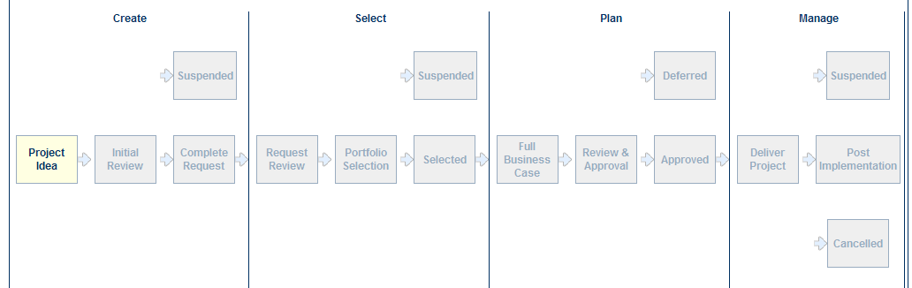
Figure 3-1 – Workflow Example

Processes:
For the example, three (3) Verification processes are defined. This implies that the project’s full business case will be completed in three stages. The first stage calls for basic data, the second stage calls for sufficient data to perform prioritization and optimization analysis, and the last stage calls for the full business case. In designing the processes, the Portfolio Server architect selects the number of processes based on the organization’s specific needs.
In this example two link processes are defined (sometimes called Transition Processes): 'Transition to Approved' and 'Transition to Rejected'. These processes are activated automatically once a project goes through the associated transitions. Other link processes can be added, as described in Chapter 2, depending on the organization’s needs.

Process Name | Type | Actions
Idea Proposal | Verification | Complete Project Information  Complete High Level Cost Estimate  Complete High Level Benefit Forecast  Complete Strategic Impact Assessments
Project Request | Verification | Complete Project Information  Complete High Level Cost Estimate  Complete High Level Benefit Forecast  Complete Risk Assessment Questionnaire  Complete Budget Resource Estimates  Complete Strategic Impact Assessments
Full Business Case | Verification | Complete Project Information  Complete Detailed Cost Estimate  Complete Detailed Benefit Forecast  Complete Risk Assessment Questionnaire  Complete Schedule  Complete Budget Resource Estimates  Complete Strategic Impact Assessments
Transition to Approved | Link | Save Requirement Values When Approved  Copy Planned Cost To Forecast
Transition to Rejected | Link | Save Requirements Values When Rejected  Save Cost Values When Rejected

Notifications:
In the example, the following notifications will be used in the lifecycle steps and in the transitions. The list includes user groups abbreviations: PM=Project Manager; PA=Portfolio Analyst; AM=Account Manager.
Notifications are primarily triggered as a project enters a specific lifecycle step. In this example, the architect wants to ensure that the Requester is informed about any lifecycle step change. In cases where the Requester does not receive a notification triggered by the lifecycle step, the architect identifies a notification associated with the transition to inform the Requester of the change. For the abbreviation of the names – see the list in the notification section of Chapter 2.

Notification Name | Feedback | Level | Email Template
Notify AM ORG FB SUSO Conf Assign | Yes | Organization | Assign
Notify PA ORG NFB Optimization | No | Organization | Optimization
Notify PM PJT FB SUSO Conf Complete Data | Yes | Project | Complete Data
Notify PM PJT NFB Deliver Project | No | Project | Deliver Project
Notify Requester PJT NFB State Change | No | Project | State Changes
Notify Requester PJT FB SUSO Conf Complete Data | Yes | Project | Complete Data
Notify Reviewer ORG FB SUSO Conf Review | Yes | Organization | Review

Email Template
The following are the email templates used in this example:

Email Template Name | Email Content
Complete Data | Dear [UserName]:  The project "[itemName]" requires your attention. Please complete the appropriate data and sign-off or move the project to the next review state.  [alertURL]&edit=true
Review | Dear [UserName],  The Project "[itemName]" is ready for your review. Please complete the review and move the project to the next appropriate state.  [alertURL]
Optimization | Dear [UserName],  The Project "[itemName]" is ready for prioritization and optimization analysis. Please include it in the next analysis session. Please move it to the next appropriate state after the analysis.  [alertURL]
Assign | Dear [UserName],  The Project "[itemName]" is ready for assignment. Please assign a Project Manager and move the project to the next step.  [alertURL]&edit=true
Deliver Project | Dear [UserName],  The Project "[itemName]" is approved for delivery. Please start the project execution per plan. This project will remain in this state during the execution. The project may continue to completion, or be suspended or cancelled. At that time, you should move the project to the appropriate state.  [alertURL]&edit=true

State Change | Dear [UserName],  The Project "[itemName]" was moved to “[workflowState]” state. Please inform all interested parties.  [alertURL]

Lifecycle Steps

In the following tables, each step is defined by name, description of purpose and objective, configuration elements, access to tabs, and transitions to next steps

The Create Phase
The following are the lifecycle steps for the Create Phase:

Lifecycle Name/Display Name | Objective/Description
Project Idea | The Requester submits the new idea by completing the required information per the associated process: project info, high level cost, high level benefit estimate, and strategic impact. The project then automatically moves to the next step of the workflow for review.
Initial Review | The Reviewer receives notification of the new idea submission and reviews it. The Reviewer can then either move the project forward to Complete Request, or put it on temporary suspension.
Suspended | The project is in temporary suspension. When the project is ready to continue through the workflow it can be manually moved back to the previous step by a user with workflow administrative permissions.
Complete Request | The Project Manager completes the project request by entering the necessary information for the budget resource, risk assessment, and the schedule. The Issues and Risks Management tab also becomes editable at this step. Once the information is completed, the project moves automatically to the next workflow Request Review step.

The Create Phase: Lifecycle Steps Configuration
The following table defines the lifecycle configuration for the Create Phase:

Configuration | Project Idea | Initial Review | Suspended | Complete Request
Sequence | 1 | 2 | 3 | 4
Automated | Yes | No | No | Yes
Notification | Notify Requester PJT FB SUSO Conf Complete Data | Notify Reviewer ORG FB SUSO Conf Review | Notify PM PJT FB SUSO Conf Complete Data | Notify Requester PJT NFB Change State
Verification Process | Idea Proposal | No | No | Project Request
Read Only | No | Yes | Yes | No
Granularity | Yearly | Yearly | Yearly | Yearly
Optimizer Status | No | No | No | No
Lock Business Case | No | No | No | No

The Create Phase: Access to Tabs
The following table defines the access settings for the Create Phase:

Configuration | Project Idea | Initial Review | Suspended | Complete Request
Project Information | Editable | Read Only | Read Only | Editable
Additional Information | Editable | Read Only | Read Only | Editable
Budget Cost | Editable | Read Only | Read Only | Editable
Budget Resource | Invisible | Invisible | Invisible | Editable
Benefit Estimates | Editable | Read Only | Read Only | Editable
Strategic Impact | Editable | Read Only | Read Only | Editable
Risk Assessment | Invisible | Invisible | Invisible | Editable
Issues & Risks Management | Invisible | Invisible | Invisible | Editable
Schedule | Editable | Invisible | Invisible | Editable
Status | Invisible | Invisible | Invisible | Invisible
Cost Tracking | Invisible | Invisible | Invisible | Invisible
Resource Tracking | Invisible | Invisible | Invisible | Invisible
Reports | Editable | Read Only | Read Only | Editable
Documents | Editable | Read Only | Read Only | Editable
Snapshot Report | Invisible | Invisible | Invisible | Invisible
Change Request Management | Invisible | Invisible | Invisible | Invisible

The Create Phase: Transitions
The following table defines the transitions for the Create Phase:

Start Step | End Step | End Step Phase | Transition Process | Notification
Project Idea | Initial Review | Create | None | None
Initial Review | Suspended | Create | None | None
Initial Review | Complete Request | Create | None | Notify Requester PJT NFB State Changed
Suspended | None | None | None* | None
Complete Request | Request Review | Select | None | Notify Requester PJT NFB State Changed
*Administrative rights are required to move the project back to one of the previous workflow stages.

The Select Phase
The following are the lifecycle steps for the Select Phase:

Lifecycle Name/Display Name | Objective/Description
Request Review | The Reviewer receives a notification to review the project. Following review, the Reviewer can move the project forward to Portfolio Selection or send it back to the previous step for further completion of the request.
Portfolio Selection | The Portfolio Analyst receives a notification that a project is ready to be included in the next portfolio optimization analysis. The Portfolio Analyst identifies the optimal set of projects that will maximize the portfolio value. Multiple portfolio selection criteria such as strategic value, financials, risk, etc, are used in the analysis. Following the optimization process, the selected projects can be moved to the Selected step and the non-selected projects to the Suspended step. The move can be automatic upon selection commitment or manual by the Portfolio Analyst.
Suspended | The project is in temporary suspension. When the project is ready to continue through the workflow it can be manually moved back to the previous step.

Selected | The Account Manager is informed that the project was selected by the optimization process. The Account Manager assigns a Project Manager and moves the project to the Full Business Case step.

The Select Phase: Lifecycle Steps Configuration
The following table defines the lifecycle configuration for the Select Phase:

Configuration | Request Review | Portfolio Selection | Suspended | Selected
Sequence | 5 | 6 | 7 | 8
Automated | No | No | No | No
Notification | Notify Reviewer ORG FB SUSO Conf Review | Notify PA ORG NFB Optimization | Notify Requester PJT NFB State Changed | Notify AM ORG FB SUSO Conf Assign
Verification Process | Project Request | No | No | No
Read Only | No | No | Yes | No
Granularity | Yearly | Yearly | Yearly | Yearly
Optimizer Status | No | No | Rejected | Select
Lock Business Case | No | No | No | No

The Select Phase: Access to Tabs
The following table defines the access settings for the Select Phase:

Configuration | Request Review | Portfolio Selection | Suspended | Selected
Project Information | Read Only | Read Only | Read Only | Read Only
Additional Information | Read Only | Read Only | Read Only | Read Only
Budget Cost | Read Only | Read Only | Read Only | Read Only
Budget Resource | Read Only | Read Only | Read Only | Read Only
Benefit Estimates | Read Only | Read Only | Read Only | Read Only
Strategic Impact | Read Only | Read Only | Read Only | Read Only
Risk Assessment | Editable | Editable | Read Only | Read Only
Issues & Risks Management | Read Only | Read Only | Read Only | Editable
Schedule | Read Only | Read Only | Read Only | Read Only
Status | Invisible | Invisible | Invisible | Invisible
Cost Tracking | Invisible | Invisible | Invisible | Invisible
Resource Tracking | Invisible | Invisible | Invisible | Invisible
Reports | Editable | Editable | Read Only | Editable
Documents | Editable | Editable | Read Only | Editable
Snapshot Report | Invisible | Invisible | Invisible | Invisible
Change Request Management | Invisible | Invisible | Invisible | Invisible

The Select Phase: Transitions
The following table defines the transitions for the Select Phase:

Start Step | End Step | End Step Phase | Transition Process | Notification
Request Review | Portfolio Selection | Select | None | Notify Requester PJT NFB State Changed
Portfolio Selection | Suspended | Select | None | None
Portfolio Selection | Selected | Select | None | Notify Requester PJT NFB State Changed
Suspended | None | None | None* | None
Selected | Full Business Case | Plan | None | Notify Requester PJT NFB State Changed
*Administrative rights are required to move the project back to one of the previous workflow stages.

The Plan Phase
The following are the lifecycle steps for the Plan Phase:

Lifecycle Name/Display Name | Objective/Description
Full Business Case | The Project Manager is informed of the assignment, completes the full business case, and advances the project to the next step of the Workflow for approval. In this step, the Project Manger may use planning tools such as Project Server 2007 or Project Professional 2007 for detailed project planning and for synchronizing the data with Portfolio Server.
Review & Approval | The Reviewer receives notification informing that the full business case is ready for review. Based on the review, the Reviewer moves the project to the appropriate step: ‘Deferred’ or ‘Approved’.

Deferred | The project is in temporary deferral. Once the project is ready to continue progressing through the workflow, it can be manually moved back to the previous step.
Approved | The Account Manager is notified of the approval, assigns a Project Manager for delivery, and moves the project to the ‘Deliver Project’ step. This step is usually followed by the project kick-off meeting. Once the project is moved to the ‘Deliver Project’ step, the budget cost and resource requirements are saved as the baseline values and are copied to the forecast table as the initial forecast. This allows the tracking of actual and forecast data for the project.

The Plan Phase: Lifecycle Step Configuration
The following table defines the lifecycle configuration for the Plan Phase:

Configuration | Full Business Case | Review & Approval | Deferred | Approved
Sequence | 9 | 10 | 11 | 12
Automated | No | No | No | No
Notification | Notify PM PJT FB SUSO Conf Complete Data | Notify Reviewer ORG FB SUSO Conf Review | Notify Requester PJT NFB State Changed | Notify AM ORG FB SUSO Conf Assign
Verification Process | Full Business Case | Full Business Case | No | No
Read Only | No | No | Yes | No
Granularity | Yearly | Yearly | Yearly | Yearly
Optimizer Status | No | No | No | No
Lock Business Case | No | No | No | No

The Plan Phase: Access to Tabs
The following table defines the access settings for the Plan Phase:

Configuration | Full Business Case | Review & Approval | Deferred | Approved
Project Information | Editable | Read Only | Read Only | Read Only
Additional Information | Editable | Read Only | Read Only | Read Only
Budget Cost | Editable | Read Only | Read Only | Read Only
Budget Resource | Editable | Read Only | Read Only | Read Only
Benefit Estimates | Editable | Read Only | Read Only | Read Only
Strategic Impact | Editable | Read Only | Read Only | Read Only
Risk Assessment | Editable | Editable | Read Only | Editable
Issues & Risks Management | Editable | Read Only | Read Only | Read Only
Schedule | Editable | Read Only | Read Only | Read Only
Status | Invisible | Invisible | Invisible | Invisible
Cost Tracking | Invisible | Invisible | Invisible | Invisible
Resource Tracking | Invisible | Invisible | Invisible | Invisible
Reports | Editable | Editable | Read Only | Editable
Documents | Editable | Editable | Read Only | Editable
Snapshot Report | Invisible | Invisible | Invisible | Invisible
Change Request Management | Invisible | Invisible | Invisible | Invisible

The Plan Phase: Transitions
The following table defines the transitions for the Plan Phase:

Start Step | End Step | End Step Phase | Transition Process | Notification
Full Business Case | Review & approval | Plan | None | Notify Requester PJT NFB State Changed
Review & Approval | Deferred | Plan | None | None
Review & Approval | Approved | Plan | None | Notify Requester PJT NFB State Changed
Deferred | None | None | None* | None
Approved | Deliver Project | Manage | Transition to Approved | Notify Requester PJT NFB State Changed
*Administrative rights are required to move the project back to one of the previous workflow stages.

The Manage Phase
The following are the lifecycle steps for the Manage Phase:

Lifecycle Name/Display Name | Objective/Description
Deliver Project | The Project Manager is informed that the project has entered the ‘Deliver Project’ step. In this step, synchronization with the Project Server 2007 can begin (if not yet started during the Plan phase) to allow optimal project execution and ongoing project and portfolio tracking.
Suspended | The project is in temporary suspension. Once the project is ready to continue through the workflow, it can be manually moved back to the previous step.
Post Implementation | The Requester is notified that the project is completed. Post Implementation benefits should be tracked. At a specific time, the Requester can mark the project as closed.
Cancelled | The project has been cancelled and work on it will not be re-initiated. Only the system administrator should be able to move the project from a cancelled step after it has gone through an exception process.

The Manage Phase: Lifecycle Step Configuration
The following table defines the lifecycle configuration for the Manage Phase:

Configuration | Deliver Project | Suspended | Post Implementation | Cancelled
Sequence | 13 | 14 | 15 | 16
Automated | No | No | No | No
Notification | Notify PM PJT NFB Deliver Project | Notify Requester PJT NFB State Changed | Notify Requester PJT NFB State Changed | Notify Requester PJT NFB State Changed
Verification Process | No | No | No | No
Read Only | No | Yes | Yes | Yes
Granularity | Portfolio Granularity | Portfolio Granularity | Portfolio Granularity | Portfolio Granularity
Optimizer Status | No | No | No | No
Lock Business Case | Yes | Yes | Yes | No

The Manage Phase: Access to Tabs
The following table defines the access settings for the Manage Phase:

Configuration | Deliver Project | Suspended | Post Implementation | Cancelled
Project Information | Read Only | Read Only | Read Only | Read Only
Additional Information | Read Only | Read Only | Read Only | Read Only
Budget Cost | Read Only | Read Only | Read Only | Read Only
Budget Resource | Read Only | Read Only | Read Only | Read Only
Benefit Estimates | Read Only | Read Only | Read Only | Read Only
Strategic Impact | Read Only | Read Only | Read Only | Read Only
Risk Assessment | Editable | Read Only | Read Only | Read Only
Issues & Risks Management | Editable | Read Only | Read Only | Read Only
Schedule | Editable | Read Only | Read Only | Read Only
Status | Editable | Read Only | Read Only | Read Only
Cost Tracking | Editable | Read Only | Read Only | Read Only
Resource Tracking | Editable | Read Only | Read Only | Read Only
Reports | Editable | Read Only | Read Only | Read Only
Documents | Editable | Read Only | Read Only | Read Only
Snapshot Report | Editable | Read Only | Read Only | Read Only
Change Request Management | Editable | Read Only | Read Only | Read Only

The Manage Phase: Transitions
The following table defines the transitions for the Manage Phase:

Start Step | End Step | End Step Phase | Transition Process | Notification
Deliver Project | Suspended | Manage | None | None
Deliver Project | Post Implementation | Manage | None | None
Deliver Project | Cancelled | Manage | Transition to Rejected | None
Suspended | Deliver Project | Manage | None | None

chapter

chapter | Workflow Configuration

Workflow Management - Overview

The Workflow Management section of the Settings includes the following sections:
- Governance Phase Management: Defines the governance phases (e.g. Create, Select, Plan, and Manage) that will become the common denominator across all workflows and will be used to group the related lifecycle steps.
- Workflows Management: Defines the workflow by giving it a name and associating it with a specific ‘Project Class’ instance. This guide assumes that at this stage the Project Class instances have already been defined as needed.
Note: When adding a new project, the user must select a specific ‘Project Class’ instance in the ‘Project Info’ tab which will identify the specific workflow the project will follow.
- Workflow Verification and Link Process Management: Defines the verification processes (a set of actions to be completed by users at each lifecycle step), and link processes (a set of actions that trigger an event), that will be used in each lifecycle step.
- Workflow Notification Management: Defines the Notifications with Feedback or Notifications without Feedback that will be linked to a lifecycle step or a transition point between lifecycle steps.
- Lifecycle Step Management: Defines the lifecycle steps to be included in each governance workflow. Lifecycle steps are individual activities or decision points in the workflow (such as the Full Business Case or the Approval lifecycle step).
- Email Templates Management: Defines the email template content and tags to be used in conjunction with the notifications.
The above represent the menu sequence in the Workflow settings of the Portfolio Server. The actual setup process follows these menu sections in sequence, except for the Email Templates Management. Email templates should be defined before the Notification setup. In addition, when in the Lifecycle Step Management section, it is best to leave the transition setup to the end.
When defining the lifecycle steps, one step will be identified as the first step where the project becomes active. For this step the architect should consider the following:
- Flag this step and all subsequent steps as ‘Lock Business Case Date’ (Post-Approval) in the lifecycle step definition screen.
- Start the Cost and Resource tracking (show these tabs in the ‘Set Step Settings’). Do not start these activities or show the tabs before this step.
- Make sure to trigger the Transition to Approved processes (A and B) in all transitions leading up to this step.

Governance Phase Management
Create the Governance Phases:
- Go to Settings > Workflow Management > Governance Phase Management
- Select the ‘Add Governance Phase’ tab
- Governance Phase Name = Create
- Click on ‘Add’
- Repeat these steps to add the ‘Select’, ‘Plan', and ‘Manage’ governance phases

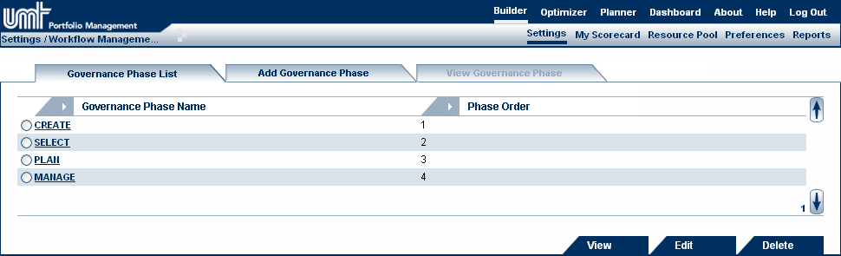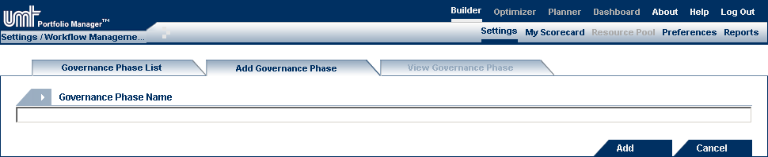
2 – Select ‘Add Governance Phase’
4 – Click ‘Add’
3 – Fill in a name for the Governance Phase

Workflows Management - Naming and Linking to Projects
Naming the workflow and associating it to a ‘Project Class’ instance allows the user to direct the project to follow a specific workflow. For this example, the Workflow is named: ‘Major Workflow’, and is linked to the ‘Major Project’ instance of the ‘Project Class’ attribute. The ‘Major Project’ instance should have been defined as part of the attribute definitions (see Chapter 5, Workflow Use Cases for details). When a project is created and the ‘Major Project’ instance is selected in ‘Project Class’ attribute, the project will follow the ‘Major Workflow’ workflow. To set this:
- Go to Settings > Workflow Management > Workflows Management
- Select the ‘Add Workflow’ tab
- Choose Workflow Name = Major Workflow
- Assign the ‘Major Project’ project class by moving it from the box on the left to the box on the right
- Click on ‘Add’. If the workflow details are updated an ‘Update’ tag appears.

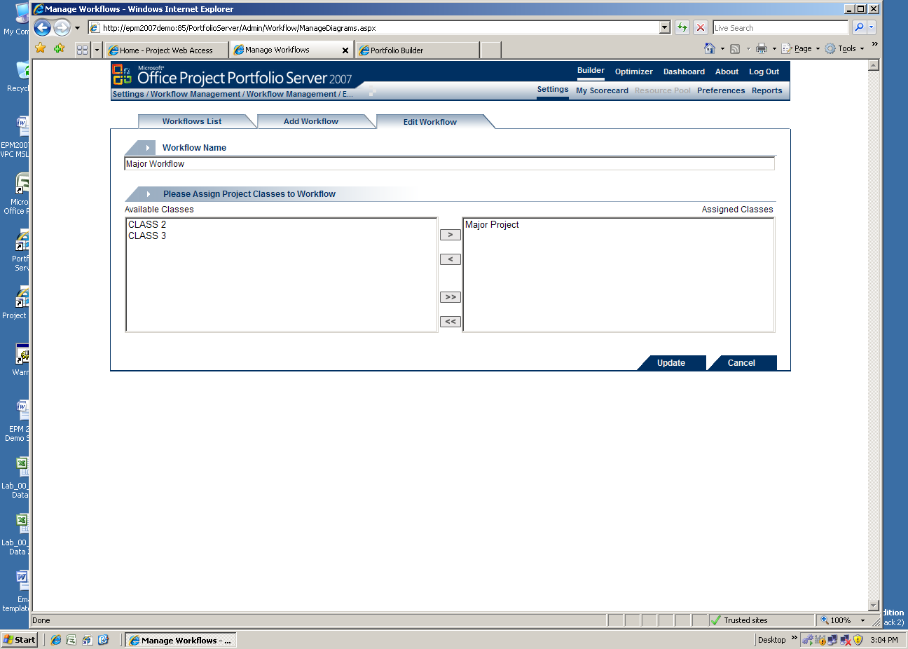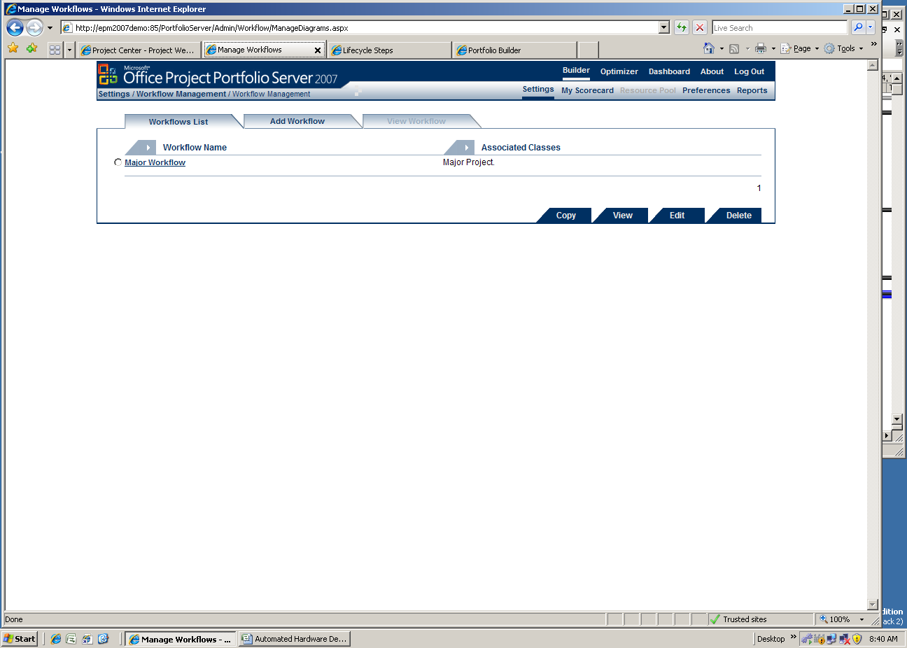
1 – Click ‘Add Workflow’
4 – Click ‘Add’ or ‘Update’
3 – Select from the available Project Classes. Refer to the Project Class attribute.
2 – Choose a Workflow Name

Verification and Link Processes Management
Use the process information defined in the ‘Develop the Workflow – An Example’ section of Chapter 3 to define the processes. There are three (3) Verification Processes and one Link Process defined. To configure them in the tool:
- Go to Settings > Workflow Management > Workflow Verification and Link Process Management
- Select the ‘Add Process’ tab
- Enter Process Name = Idea Proposal
- Enter Process Type = Verification Process
- Enter Process Actions = Select all the actions listed for this workflow
- Click on ‘Add’
- Repeat these steps for the rest of the processes

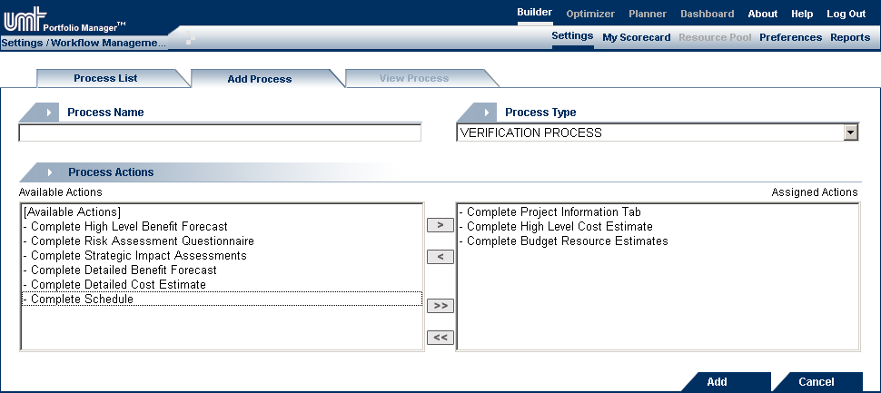
6 – Click ‘Add’
3, 4 – Enter Process Name and Process Type
5 – Choose the appropriate Process Actions

Once the processes are defined, the summary should look as follows:

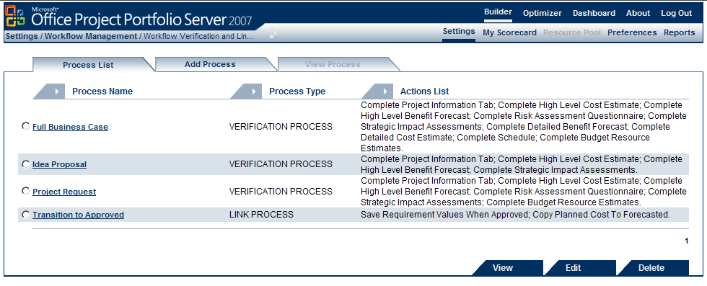

Email Templates
To create the necessary email templates to be used in the workflow, use the information provided in the ‘Develop the Workflow – An Example’ section of Chapter 3. To configure:
- Go to Settings > Workflow Management > Email Templates Management
- Select the ‘Add Template’ tab
- Template Name = Complete Data
- Template Type = Workflow Email Templates
- Template Body:

Dear [UserName]:

The project "[itemName]" requires your attention. Please complete the appropriate data and sign-off or move the project to the next review state.

[alertURL]&edit=true

- Click on ‘Add’
Note: the tag ‘[alertURL]&Edit=true’ will open the project (or entity) in edit mode.

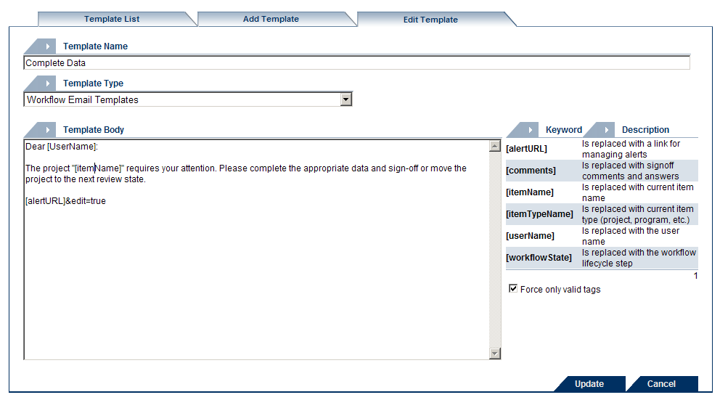
5 – Fill in the email body using the valid keywords on the right
6 – Click ‘Add’ or ‘Update’
3, 4 – Fill in a name and choose Template Type ‘Workflow Email Templates’

Workflow Notification Management
Use the notifications information provided in the ‘Develop the Workflow – An Example’ section of Chapter 3 to define the required notifications. To configure:
- Go to Settings > Workflow Management > Workflow Notification Management
- Select the ‘Add Notification’ tab
- Name = Notify AM ORG FB SUSO Conf Assign (The name carries all the information about this notification. When triggered, it will notify the Account Manager(s) on the Organization level that a project manager needs to be assigned, and it will require feedback of Single User Sign-Off with Confirmation type response.)
- Email Template = Complete data
- Notification Level = Organization
- User Group = Account Manager
- Select ‘Notification with Feedback’
- Response Technique = Standard (Requires Single User Sign-Off)
- Response Type = Confirmation
- Click on ‘Add’
- Create the remaining notifications. If needed, use the information within their name to select the appropriate setup variable.
Note: Use the abbreviations in Notification Name to select the correct one (e.g. Notify PA ORG NFB: User Group = Portfolio Analyst, at the Organization level, Notification with no feedback)

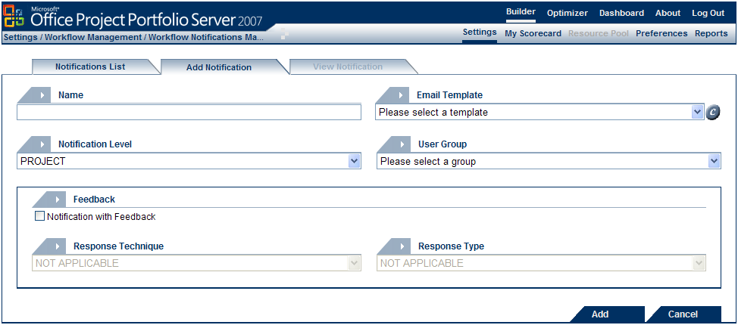
10 – Click ‘Add’
3-9 – Fill in Name, Email Template, Notification Level, User Group, Feedback check, Response Technique and Response Type

Once the notificaitons are defined, the summary will look as follows:
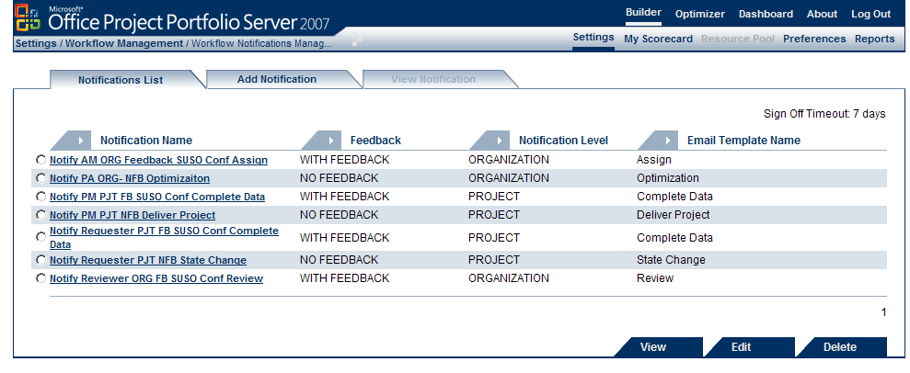

Lifecycle Step Management
Use the lifecycle step information provided in the ‘Develop the Workflow – An Example’ section of Chapter 3 to define the required steps. To configure:
- Go to Settings > Workflow Management > Lifecycle Step Management
- Select the “Add Lifecycle Step” tab
- Complete the page using the information in the two charts above
Note: Name and Display Name should be the same
- Name = Project Idea
- Governance Phase = Create
- Objective = [copy and paste the corresponding descriptions]
- Type = select the ‘Automatically move forward to next step’ checkbox
- Associated Notification = Notify Requester PJT FB SUSO Conf Complete Data
- Associated Verification Process = Project Request
- Project Read/Write = [Leave box unselected]
- Project Granularity = Yearly
- Optimizer Status = No Status
- Dashboard Status = Lock Business Case Data (Post-Approval) [leave unselected]
- Click ‘Add’
- Repeat the above steps to create the remaining lifecycle steps.
Note: If a step is defined as ‘Automatic’ or has a process associated to it, it requires a notification with feedback and only the notification with feedback will be available for selection.

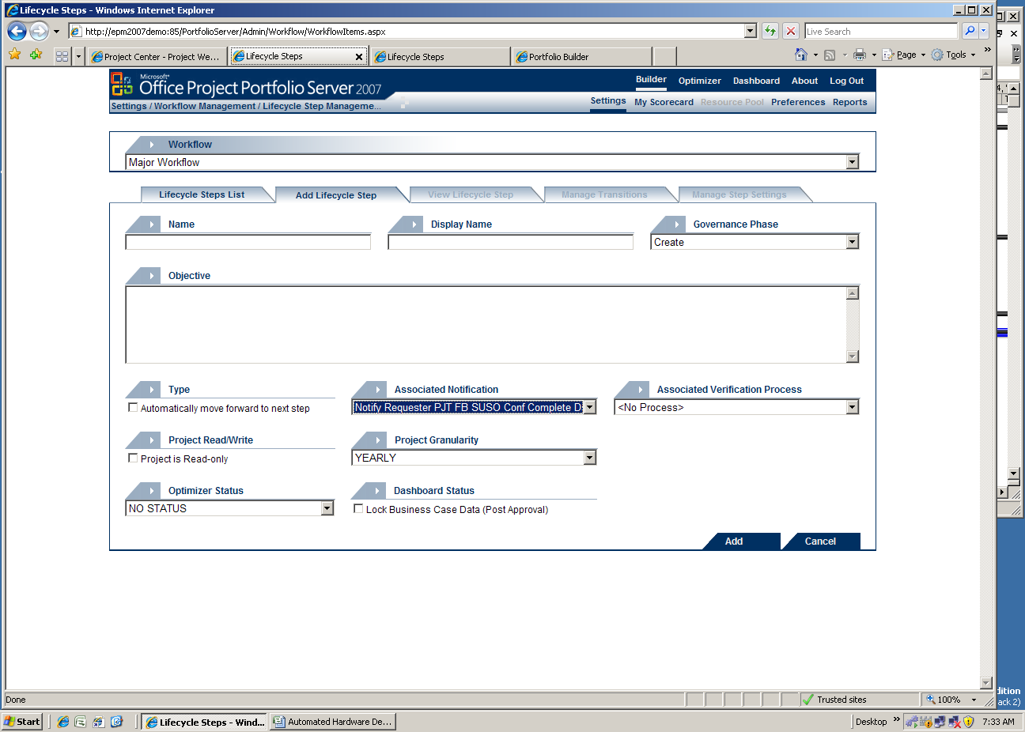
3-6 – Fill in all information:
Name (shown as ‘Workflow Status’ in Builder)
Display Name (shown on workflow graph)
Governance Phase
Objective (shown in pop-up balloon on workflow graph)
7-9 –Choose whether the lifecycle step is an automatic step
Select the Default Associated Notification (users receiving this notification can move the project to the next step in the Workflow)
(optional) Select a Verification Process if appropriate

4 – Click ‘Add’
10-13 –Choose whether the lifecycle step is Read-Only (all tabs) or not
Select the Project Granularity as ‘Yearly’ or ‘Monthly’/’Quarterly’
Select an Optimizer Status if applicable
Check whether the lifecycle step is ‘Post-Approval’ or not

Once the lifecycle steps are defined, the summary list will look as follows:

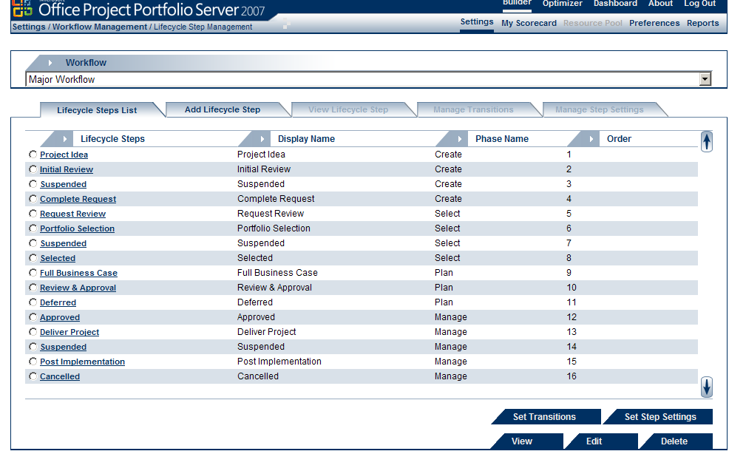

Setting the Lifecycle Step - Access to Project Tabs
Use the lifecycle step information provided in the ‘Develop the Workflow – An Example’ section of Chapter 3 to define the settings for the steps. To configure:
- Go to Settings > Workflow Management > Lifecycle Step Management
- Select the first lifecycle step (Project Idea) and click on ‘Set Step Settings’ at the bottom
- Use the chart in Chapter 3 to select the correct access settings for each tab in the list
- Click on ‘Update’ at the bottom
- Repeat these steps for all the lifecycle steps

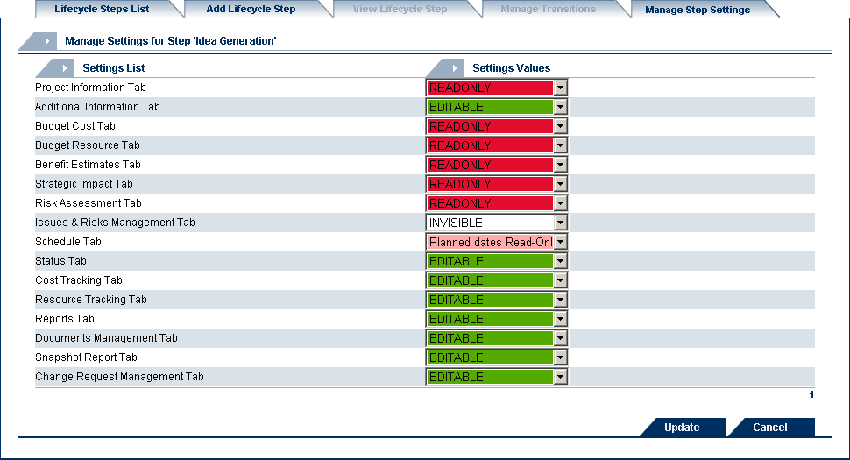
3 – Select ‘EDITABLE’, ‘READONLY’ or ‘INVISIBLE’
4 – Click ‘Update’

Transitions and Sequencing
Use the lifecycle step information provided in the ‘Develop the Workflow – an Example’ section of Chapter 3 to define the transition for each step. To configure:
- Go to Settings > Workflow Management > Lifecycle Step Management
- Select the first lifecycle step (Project Idea) and click on “Set Transitions” at the bottom
- Click on ‘Add’
- Use the information in Chapter 3 to enter the End Step, the Transition (or Link) Process and the assigned notification.
- Click ‘Add’
- Repeat the above steps to create all the transitions from the chart.
Note: Make sure to add the 2nd and 3rd transitions for the appropriate steps (e.g. ‘Deliver Project’ step has three transitions)

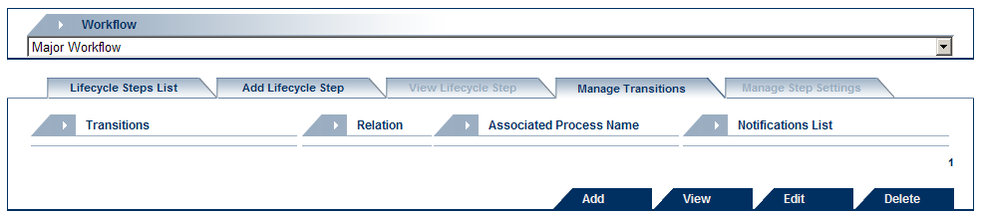
3 – Click ’Add’

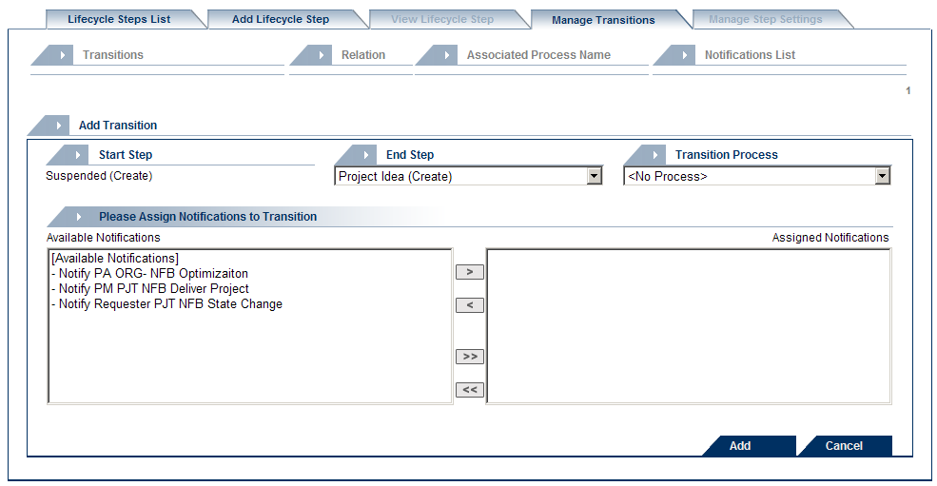
4 – Select the end lifecycle step, the transition process, and the notifications (optional)
5 – Click ‘Add’

Once the transitions are defined, the transitions for the ‘Deliver Project’ step will look as follows:

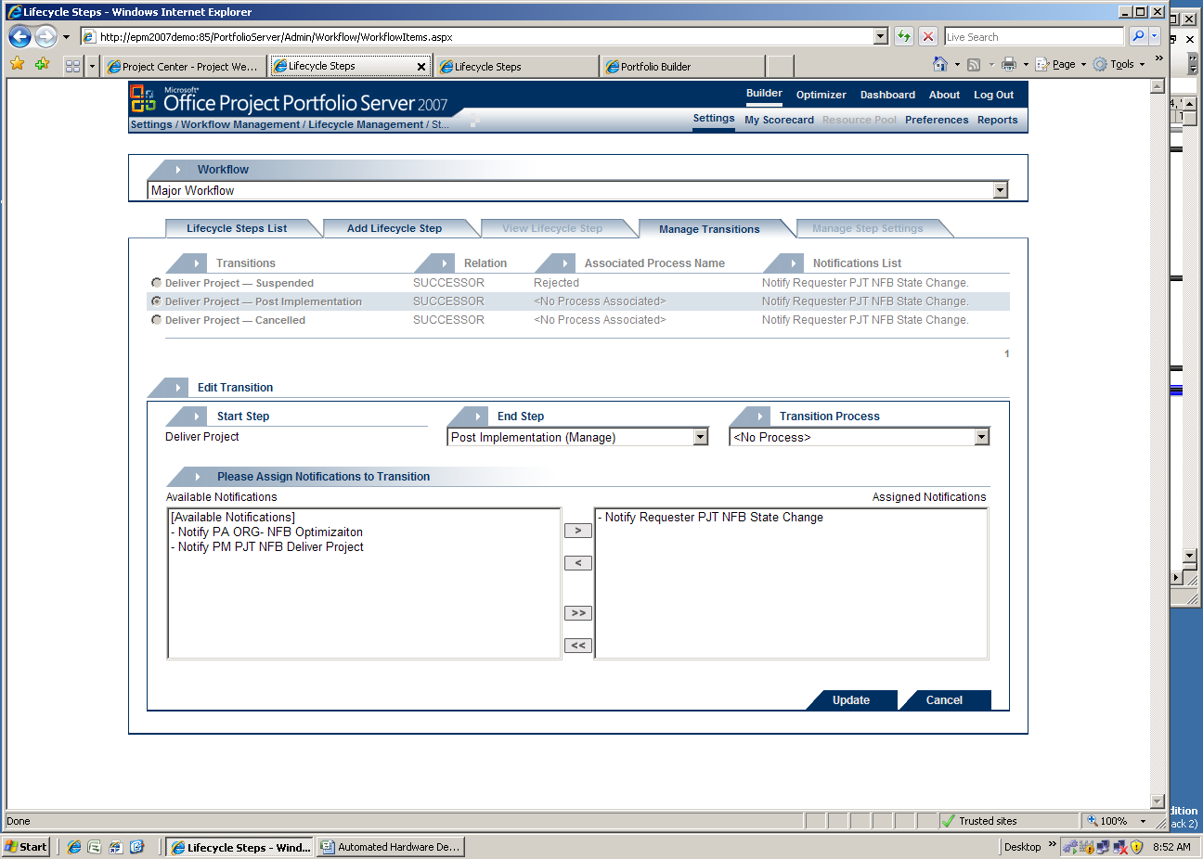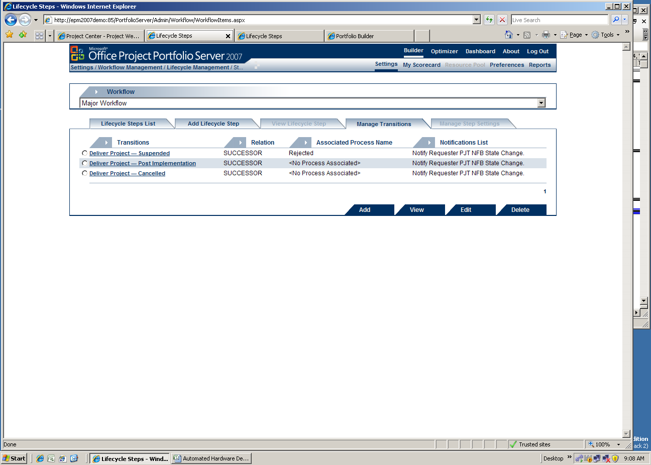

chapter

chapter | Workflow Use Cases

Assign and View the Workflows for Projects
To assign a workflow to a project:
- Go to the ‘Project Info’ tab
- Select the appropriate ‘Project Class’ instance.
In the example below, the attribute identifies three instances: Major Project, CLASS 2, and CLASS 3. If the ‘Major Project’ instance is selected, the project will follow the workflow associated with this instance.
Note: Once a project is created, an instance of ‘Project Class’ must be selected.
To check which lifecycle step of the workflow the project is currently in:
- Go to the ‘Project Info’ tab. The ‘Project Class’ instance identifies the name of the workflow and the ‘Workflow’ attribute identifies the current lifecycle step.
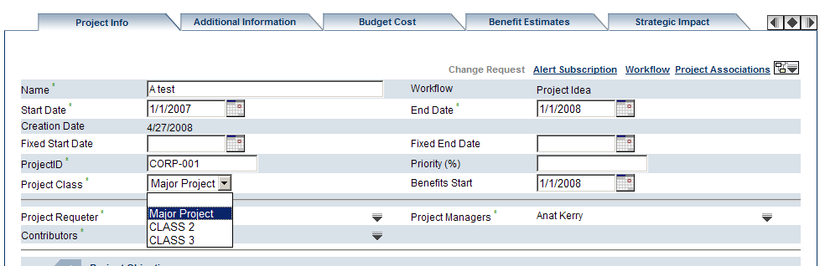
Figure ‎5-2 Project Info Tab – ‘Project Class’ instances and Workflow Access
- To see the workflow graphically, click the workflow button on the upper-right side of the page. The project workflow is displayed graphically with the current workflow step highlighted.

Figure ‎5-3 Project Workflow

- Rest your mouse cursor over a workflow step to display a pop-up window that provides additional information (if available) on that step.
- To close the flowchart window, click the workflow button again.

Accessing the Workflow Page:
To access the Workflow page:
- Go to the ‘Project Info’ tab.
- Click the ‘Workflow’ hyperlink at the upper-right portion of the screen.
The following page with a list of the workflow steps will appear:

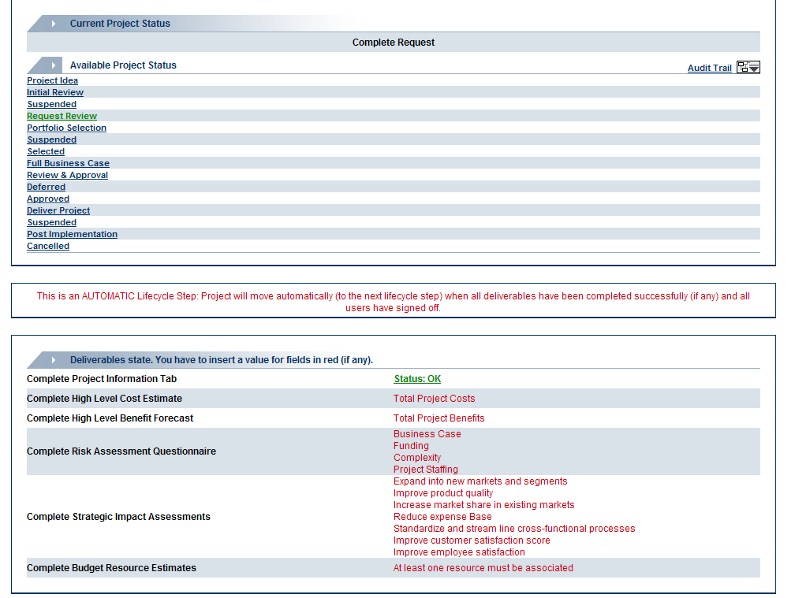
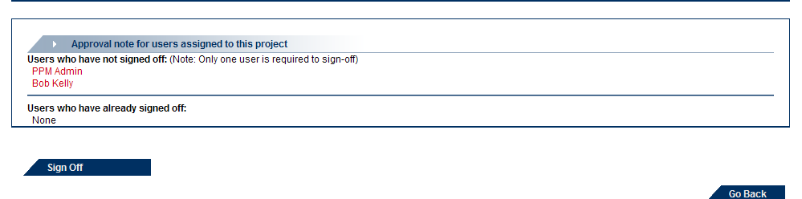
Figure ‎5-4 Workflow Tab

The first section of the Workflow Tab shows the current project status. Below that, all the potential lifecycle steps are listed. The green color identifies the next available lifecycle steps.
In the section below that, the current workflow step is described as either Manual or Automatic. The project will be manually moved to the next lifecycle step by the authorized user – except when the step is defined as Automatic and there is only one step to move forward to. In this case, the step is defined as ‘Automatic’ and can move automatically upon sign-off.
The third section shows the state of all of the deliverables for the lifecycle step. In the example above, only the ‘Project Info’ tab is completed; the cost, benefits, risks, strategic impact, and resources are not.
The last section lists the users who have or have not signed-off on the project in the specific lifecycle step, and the button required for sign-off.

Accessing the Workflow Audit Trail Screen
To view the workflow activity history of the project, users can explore the Audit Trail information by clicking on the ‘Audit Trail’ hyperlink on the upper-right corner of the tab.

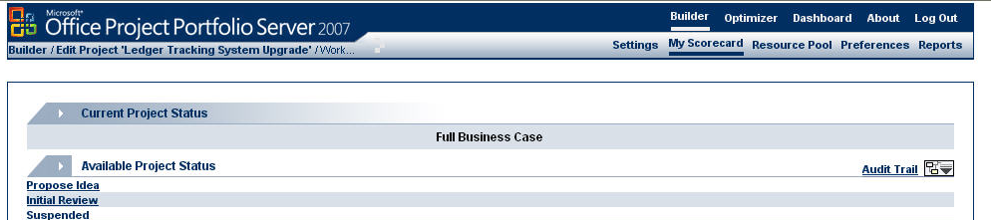
Figure ‎5-4 Audit Trail link

The ‘Audit Trail’ page appears as follows.

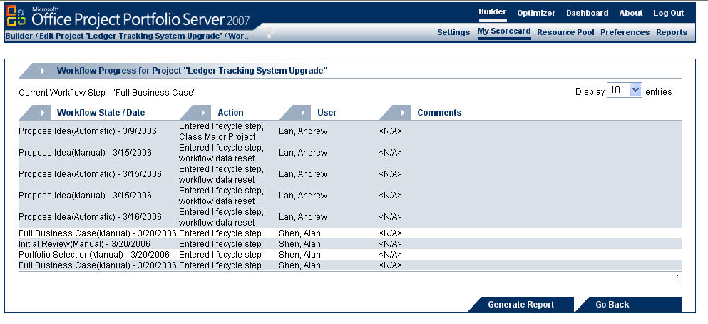
Figure ‎5-5 Audit Trail Page

The ‘Audit Trail’ page depicts all activities, their time and date, the user who performed them and any comments added.

Transitioning Projects through the Lifecycle
The project transitions from one lifecycle step to another, either manually or automatically. When the step is ‘manual’, the authorized user must manually move the project from that step to the next. When the step is ‘automatic’, the transition requires a sign-off before the project can move forward. However, the actual transition will be automatic (without intervention) only if there is one step going forward and no more than one step going backward. For automatic lifecycle steps that have more than one next step going forward, the authorized user must move the project manually.

Manual Step Transitions
For manual transitions:
- Go to the ‘Workflow’ tab that is reached from the ‘Project Info’ tab. Select the next step from the list of available lifecycle steps. Users may see either all steps or only the next steps. When all steps are listed, the available lifecycle steps will be colored green. Typically, only the administrator should have permission to move the project to non-successive steps.
- Click ‘Go Back’ to return to the ‘Project Info’ tab.

Automatic Step Transitions
For automatic transitions:
- Go to the ‘Workflow’ tab found in the ‘Project Info’ tab. Verify that all deliverables are met (the list of deliverables are marked ‘OK’ in green letters).
- If the status of any of the deliverables is red, return to the specific tab and complete the information requested.
- Click ‘Sign-Off’, at the bottom of the page.
Portfolio Server directs you to a project approval screen, where you can approve (Approve/Reject) or confirm (Yes/No) and add comments to explain the decision.
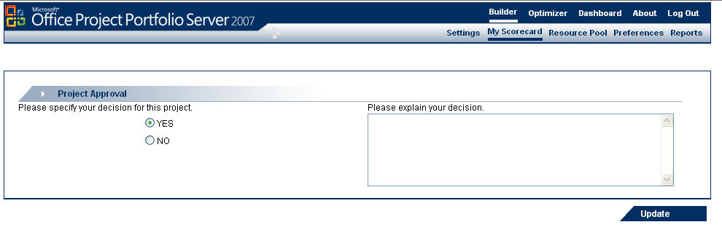
Figure ‎5-6 Workflow Sign-Off Screen

- Click ‘Update’ to apply your selection.
- Click ‘Go Back’ to return to the ‘Project Info’ tab.

Alert Subscriptions
The Alert Subscription option of the Builder module allows the users to set up email alerts whenever project-specific events occur. Each user that can view the project information has the right to subscribe and manage project-specific alerts using the Alert Subscription hyperlink located at the top right of the ‘Project Info’ tab.
Note: Users can only add subscriptions to projects in workflow steps where the ‘Project Info’ tab is editable.
There are five types of alert triggers in Portfolio Server. Each can be associated with specific attributes and alert the subscriber to any change in data values. Each trigger type will use a pre-defined email template. The trigger types are:
- Projects Created – sends an alert to the user when projects are created in a custom portfolio or organization. This is the only alert set at the portfolio level and not at the project level.
- Workflow Status Changed – sends an alert when a specific project reaches a specific workflow step, or when the workflow status is changed to a specific value.
- Indicator Color Changed – sends an alert to the user when a specific indicator is changed to a specific color in the current Project Snapshot report (‘Project Status’ tab).
- Attribute Value Changed – sends an alert when a specified attribute value has been changed and saved. The criteria for changes in ‘List’ type attributes can specify the new instance selected as a criterion for the alert trigger. For ‘Numeric’ type attributes the comparison operators (>, <, =>, =<) can also be used to specify the trigger.
- Entry Items Created – sends an alert whenever a project issue, risk, or change request is added.
Only two triggers relate to the workflow. The first issues an alert when a project is created and has entered the first step of the associated workflow. The second is for workflow status change that alerts the users to changes in the project lifecycle step.
Creating Alert Subscriptions
- On the ‘Project Info’ tab, click ‘Alert Subscription’
- Select the ‘Add Subscription’ hyperlink that will present the ‘Add Subscription’ tab

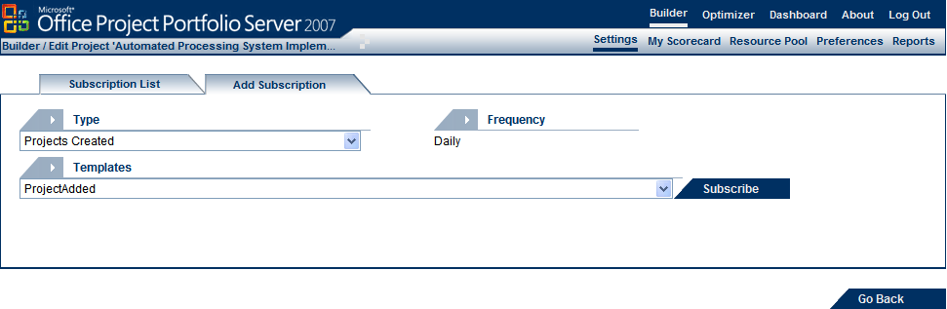
Figure ‎5-7 Add Subscription Tab

- Select the ‘Type’ of subscription to create from the list at the top of the tab

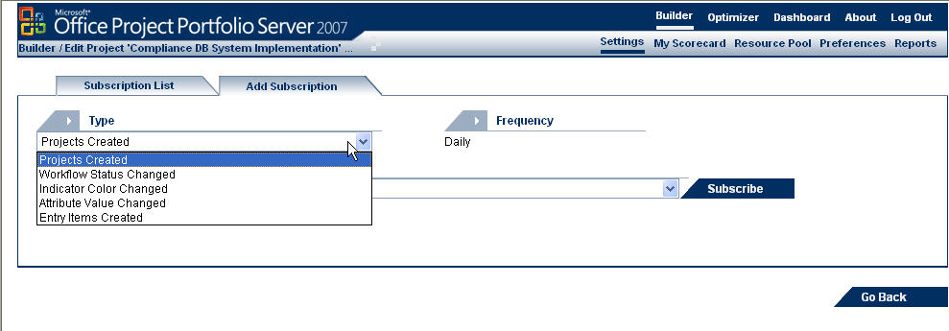
Figure ‎5-8 Alert Subscription Menu

- Select the email template to be used from the ‘Templates’ list, click ‘Subscribe’ and the following screen appears:
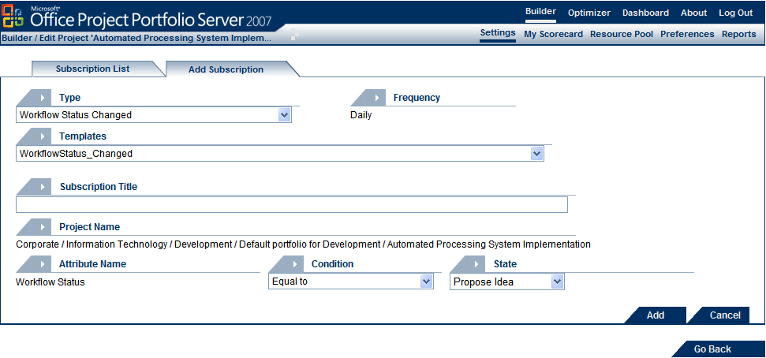
Figure ‎5-5 Alert Subscription - Workflow Status Changed

- Type a title for the subscription in the ‘Subscription Title’ field
- Select the additional conditions for the alert from the ‘Attribute Name’, ‘Condition’, and ‘Value’ fields
- Click ‘Add’ to save the alert and list it on the ‘Subscription List’ tab as follows:

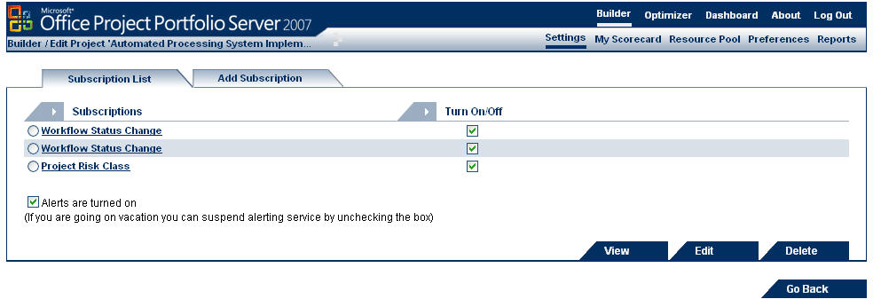
Figure ‎5-10 Subscription List Tab

Reporting

Report Templates
The reporting framework includes a set of fourteen (14) Organization and Portfolios report templates that can be tailored to depict specific information about the projects (see figure below). Users requiring reports associated with workflows can use these templates to create the types of reports they need.
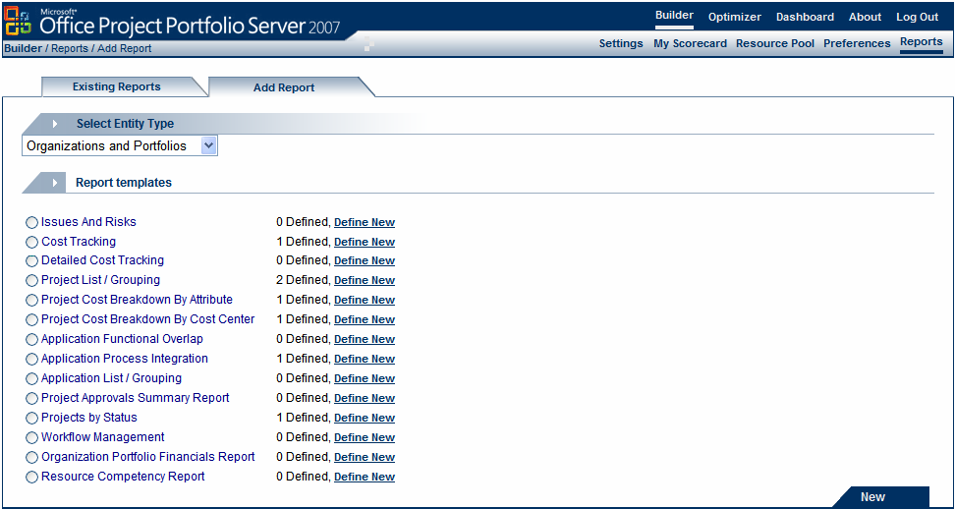
Figure ‎5-6 Add Report Tab – Template List

Some of these templates are associated with workflow reporting:
- Cost Tracking - Creates user-selected cost information reports (both estimated and tracked) using the workflow gates or lifecycle steps as constraints. Also allows for indicator inclusion.
- Detailed Cost Tracking – Creates the same type of reports as the Cost Tracking report, but also allows the user to select the cost structure level and timeframe of the cost data.
- Project Approvals Summary Report - Creates reports of project lists with user-defined attributes and cost data based on the workflow phase. In addition, it displays how long each project has been in the user-defined workflow stage.
- Projects by Status - Creates reports of project lists with user-defined cost and attribute data by workflow lifecycle steps. It also displays the number of projects in each workflow lifecycle step in a pie chart.
- Workflow Management - Creates reports of project statistics in a specific lifecycle step over a period of time. Examples of such statistics include the total number of projects that moved to their next lifecycle steps, the total number of projects that entered a selected step, and the average time each project has spent in a lifecycle step.

Creating a Report from a Template
Users with appropriate rights can create new reports by customizing report templates. The options for customizing a report template vary by template (reflecting the report topic) but there are a few general option types:
- Report Scope – Select the portfolio(s) based on organizations, a set of child organizations, or pre-defined filters.
- Topic Parameters – Each report template has a general topic (such as workflow), which may be organized by parameters (such as phases or steps). Often a template will allow the user to focus on a specific subset of projects by a specific topic. For example, the figure below shows an option to select specific workflow steps in Workflow Management report template.

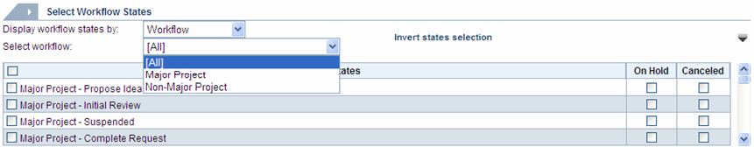
Figure ‎5-12, Report Parameter Example

- Attributes and Indicators – Many report templates enable you to add columns of attributes or indicators for the projects in the report as an extension of pre-defined columns or as a new section of the report.
- Information Sections – Reports may identify several informational sections to be included and users may choose to include or omit each section.
- Financial Detail Level and Scope – Report templates that include financial sections allow the user to select the level of detail of financial structures and the time period to be covered.
- Administrative Data – Users can select the report name, description, and whether the project is private or public.

Workflow changes
At times, the current workflow may require changes. Before performing any change, the administrator should ensure that the potential impact is clearly understood.
The following is an assessment of the expected impact and recommended actions associated with changes in the ‘Workflow Management’ section of the Settings.
  - Governance Phase Management: Adding a new Phase and inserting it in between existing ones, or changing the order of existing phases might have an impact on the steps and their linkages. The degree of impact depends on the actual change and the affected projects. The administrator should perform the changes in a parallel testing environment before completing them in the production environment.
  - Workflows Management: Adding a new workflow will not have any impact until it is associated with a ‘Project Class’ instance and linked to a project. In the case where a new workflow needs to replace an old one, there are two options. The first is to allow all old projects to continue with the old workflow and link only new projects to the new one. The second is changing the ‘Project Class’ instance and linking the project to the new workflow. This will send the newly linked project to the first step of the new workflow. In this case, the administrator should document each project’s workflow step and identify where they should be in the new workflow. Once the change takes place, the administrator should move the project to the appropriate step in the new workflow. During such a change, the ProjectID is retained, the project enters the first step of the new workflow (but can later be moved to the appropriate state), and the Audit Trail is updated to reflect the new workflow position, while all old workflow Audit Trail entries are kept.
  - Verification and Link Process Management: Creating or modifying existing Processes will affect the behavior of the workflow at the steps where the Processes are used.
  - Workflow Notification Management: Changing a notification for one of the lifecycle steps will affect projects entering this step but will not affect the projects currently in that step.
  - Lifecycle Step Management: Modifying a lifecycle step that holds projects will automatically send those projects to the first step of the workflow. (Note that the tool provides a warning to inform the user of this action.) The administrator should document what steps each affected project was in before the change and move those projects back to those steps after the change. Additionally, if a new step is inserted between current ones, some of the existing step transitions will be broken. The administrator should take note of the configuration before the change and restore the required ones after the change.
  - Email Templates Management: Changing an email template will only affect future notifications that use it.
It is recommended that organizations establish procedures, including documentation and testing methods, before undertaking such changes.

Modifying the ‘Project Class’ Attributes
The Portfolio Server includes a default attribute named ‘Project Class’. It is a ‘List’ type attribute and allows for one of several instances to be selected. Each instance of this attribute can identify a workflow and each project must select an instance for this attribute in the ‘Project Info’ tab. Once the instance is selected, the project will follow the corresponding workflow starting from the first step.
To add, delete, or update instances, the administrator should go to the Settings > Attribute and Indicator Management > Attribute Definition, and select the option that lists the default attributes, then select the ‘Project Class’ attribute from the list and click ‘Edit’. The following screen will be presented.
In this screen, highlight the instance that needs to be updated or deleted and click on the appropriate icon. To add an instance, enter the ‘Instance Name’ and click on ‘Add’.
When the changes are completed, click on the ‘Update Attribute’ icon at the bottom of the page to save the changes.

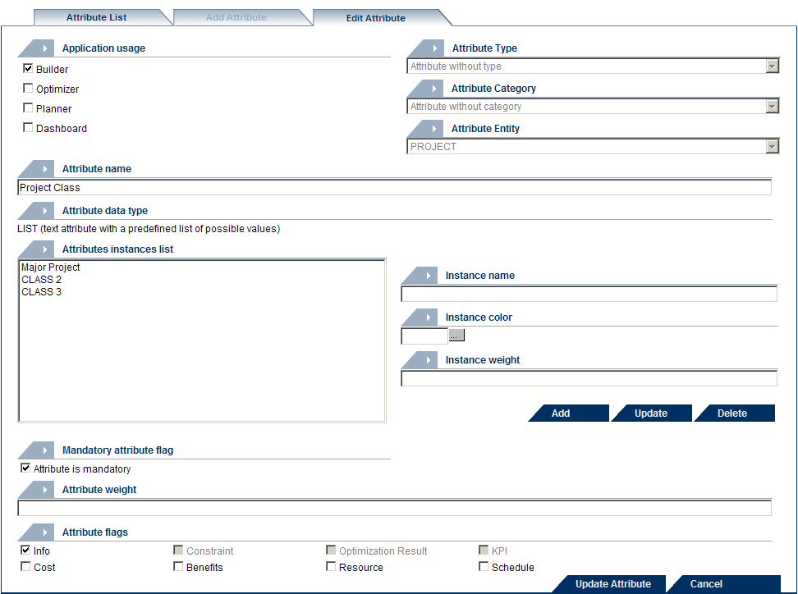
Figure 5-7 List Type Attributes Definition Screen - Project Class

Other Workflow Related Uses

Filters:
Users may utilize the project workflow status to filter projects that belong to a specific lifecycle step. A filter can be created to select projects based on specific instances of the ‘Project Class’ attribute – that is, projects that follow a specific workflow. This type of filter may be used in setting My Scorecard views, creating reports, performing analysis, and interacting with Project Server via the Gateway. The figure below is an example of the data entry screen to set such a filter.

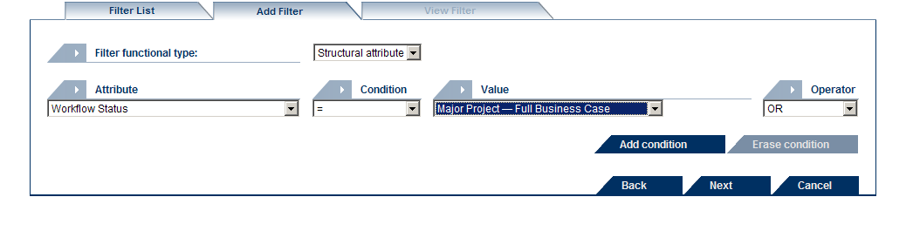
Figure 5-8 Data Entry Screen for Filters

Preference:
Users who require to see tailored views of ‘My Scorecard’ in the Builder and the Dashboard modules, that include information about the project workflow and lifecycle step, can create a column and select to display the workflow class and the workflow state. The figure below is an example of setting a view with this information.

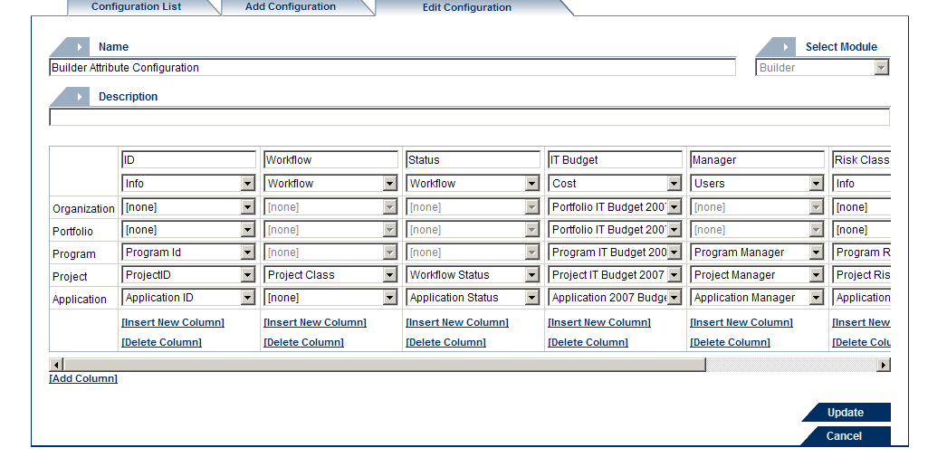
Figure 5-9 List Type Attributes Definition Screen - Project Class

When the Business Process doesn't require a Workflow
To use the full capability of the Portfolio Server and the Workflow function requires a high level of Portfolio Management maturity. Organizations that are interested in using the Portfolio Server only as a project repository and tracking tool do not have to use the capabilities of the workflow function.
In such cases, Administrators are still required to create at least a workflow with one step, and associate it to the appropriate instances of the Project Class. For this workflow step, the Administrators can set the visibility for all project tabs as necessary.

This is highly recommended for insuring an accurate and consistent behavior among the project tabs.
chapter

chapter | Appendix

References

The Portfolio Server Technet Site
This site includes various Portfolio Server Documents released by Microsoft.
Project Portfolio Server 2007 Document: Deployment Guide
This guide describes how to install Microsoft Office Project Portfolio Server 2007 in a stand-alone environment, and in a server farm environment.
Project Portfolio Server 2007 Document: Optimizer User Manual
This manual details how end-users can use the Microsoft Office Project Portfolio Server 2007 Optimizer features.
Portfolio Server 2007 Evaluation
Microsoft Office Project Portfolio Server 2007 helps your organization realize its potential by identifying, selecting, managing, and delivering portfolios that align with your strategic priorities.
Project Portfolio Server 2007 Document: Builder User Manual
This manual details how end-users can use the Microsoft Office Project Portfolio Server 2007 Builder features.
Project Portfolio Server 2007 Document: Dashboard User Manual
This manual details how end-users can use the Microsoft Office Project Portfolio Server 2007 Dashboard features.
Project Portfolio Server 2007 Document: Programmer Reference
This Programmer Reference for Microsoft Office Project Portfolio Server 2007 contains scripts to migrate databases, reports, and Windows SharePoint Services passwords from older versions of Project Portfolio Server to Project Portfolio Server 2007.
Portfolio Server 2007 SP1
Microsoft Office Project Portfolio Server 2007 helps your organization realize its potential by identifying, selecting, managing, and delivering portfolios that align with your strategic priorities. The site links to the Portfolio Server 2007 PS1 version.
Project Portfolio Server 2007 Home Page
This site includes product information for Portfolio Server.
SQL Server 2005 Features Comparison
This site provides comparison of the SQL Server 2005 product family.

